

Project Title:

Cosmetics Sales Analytics

Prepared By:

Ahmed Mohamed Gomaa

Ahmed Ayman Sobieh

Salma Essam AbdelMoty

Aliaa Youssef El-Sepay

Mona Ashraf Rizk

Supervised By:

Eng. Nada El-Araby

INFORMATION TECHNOLOGY INSTITUTE

4-MONTH PROGRAM – ICC R3 – PortSaid

GRADUATION PROJECT

****Table of Contents: -****

|  |  |
| --- | --- |
| **Introduction** | **1** |
| **Project Description** | **1** |
| **Business Objectives and Success Criteria** | **1** |
| **Stakeholders** | **2** |
| **Vision** | **3** |
| **Scope** | **3** |
| **Assumptions and Dependencies** | **3** |
| **Risks** | **4** |
| **Resources** | **5** |
| **Project Management Plan** | **5** |
| **Project Plan and Full Features List** | **6** |
| **Dashboard Design and Features** | **8** |
| **Website Features** | **13** |
| **TECHNOLOGIES USED** | **13** |
| **FUTURE Works** | **14** |
| **APPENDICES** | **15- 66** |

****ACKNOWLEDGEMENT****

We would like to express our sincere gratitude to our beloved country, our families, and friends for their unwavering support throughout this project. Their encouragement and belief in our capabilities have been a constant source of strength and motivation.

A special thanks goes to everyone at the ****Information Technology Institute (ITI)**** - a place that truly develops countries by developing people. We are deeply thankful for the learning environment, mentorship, and resources provided to us during this journey. Without the guidance and support of our instructors, mentors, and peers, this project would not have been possible.

To all who inspired us, challenged us, and believed in us -

Thank you.

Abstract

**In A Competitive Cosmetics Market, Understanding Customer Behavior and Product Performance Is Key to Driving Growth. This Project Delivers a Powerful Power Bi Dashboard That Turns Raw Sales Data into Actionable Insights. Through Dynamic Visuals, Trend Analysis, Branch-Level Performance Tracking, The Solution Empowers Business Users to Make Faster, Smarter Decisions. It Lays the Foundation for an Insight-Driven Culture and Sets the Stage for Future Integration with Ai-Driven Recommendations and Predictive Analytics.**

****INTRODUCTION****

****Project Description****

This project presents a complete data-driven solution for a cosmetics business, combining a business intelligence dashboard and a customer-facing e-commerce website. The Power BI dashboard provides interactive analysis on sales, customer behavior, and product performance. The website serves as a user-friendly platform for showcasing cosmetics products, managing customer accounts, and enabling online purchases. Together, they provide a seamless environment for both internal stakeholders and end-users.

Business Objectives and Success Criteria

****Objectives:****

Provide dynamic analytics on product, branch, and customer performance.

Enable online visibility and sales of cosmetics products.

Integrate marketing insights with user behavior data from the website.

Offer stakeholders a clear and visual summary of KPIs.

****Success Criteria:****

Accurate, real-time Power BI dashboards.

Smooth integration between website and data model Positive feedback from both internal users and customers.

****Stakeholders****

|  |  |  |  |  |
| --- | --- | --- | --- | --- |
| Stakeholder | Major Value | Attitudes | Major Interests | Constraints |
| Business Owners / Executives | Informed decision-making through reliable sales and customer insights | Supportive of analytics but expect quick ROI | Revenue growth, customer satisfaction, product visibility | Budget limitations, quick deployment |
| Sales & Marketing Team | Actionable insights to improve campaigns and boost conversions | Enthusiastic, data-hungry | Customer segmentation, high-performing products, trends | Require training, may resist dashboard UX changes |
| Web Development Team | Platform scalability, performance, and integration | Collaborative and technically oriented | Clean code, responsive UI, backend reliability | Timeline and feature creep |
| BI / Data Team | Data quality, transformation accuracy, and model scalability | Analytical and process-driven | Clean data model, refresh automation, custom DAX logic | Data inconsistencies, integration delays |
| Customers (Website Users) | Easy browsing, personalized shopping experience | Highly sensitive to UX and performance | Product search, reviews, smooth checkout | Limited tech awareness, short attention span |

****Vision****

“To empower decision-makers and enhance customer engagement through data-driven insights and a seamless digital experience.”

This project aims to provide a unified solution for cosmetics businesses through two core components:

* An interactive Power BI dashboard that helps internal stakeholders make smarter decisions by analyzing sales, customer behavior, and product performance.
* A user-friendly cosmetics website that showcases products, supports e-commerce functionality, and reflects brand identity.

The long-term vision is to integrate advanced analytics, customer personalization, and marketing automation into both platforms. This will enable the business to grow competitively in both physical and digital markets while building deeper customer loyalty and operational excellence.

Scope

Initial Release

* Deployment of a Power BI dashboard including:

Sales overview by branch, category, and date.

Customer segmentation and behavioral trends.

Product performance and inventory indicators.

* Launch of a responsive cosmetics e-commerce website

Assumptions and Dependencies

Assumptions

* Sales, customer, and product data is correct and consistent in all branches.
* Users like the sales and marketing teams can use the Power BI dashboard easily with little or no training.
* The team knows how to use tools like Power BI, SQL, and web development software.
* Customers can easily use the website to browse and shop for products.
* The internet will be available when needed to refresh data and run the website and dashboard.

Dependencies

* Data Sources: The dashboard needs clean and up-to-date data from Excel files, databases, or online sources.
* Login System: The website needs a working and secure login system so users can access their accounts safely.
* Power BI Service: The dashboard depends on Microsoft Power BI services to refresh data and share reports.
* User Participation: The project depends on users (staff and managers) using the dashboard and giving feedback.
* Browser Support: The website should work properly on popular browsers like Chrome, Edge, Safari, and Firefox.

Risks

* Data Quality and Consistency: Incomplete or inconsistent sales, customer, or product data could affect dashboard accuracy and insights.
* Integration Issues: Ensuring seamless data flow between the website, the backend database, and Power BI may present technical challenges.
* User Adoption: Stakeholders may be slow to adopt the dashboard or may require training to fully utilize its features.
* Website Security: Handling customer data and transactions online introduces cybersecurity risks that must be mitigated.
* Timeline Constraints: Aligning dashboard delivery with website development milestones may lead to delays if unforeseen challenges arise.
* Market Competition: Many cosmetics websites already exist. Our platform must differentiate through branding, UX design, and data-powered insights.

Resources

* Team Members:
* The team consists of five individuals:
  + Two members specialize in Power BI development and data modeling.
  + Two full-stack web developers experienced building responsive websites.
  + One data analyst is responsible for data cleaning, transformation, and KPI definition.
* Hardware Resources:
* Personal laptops and development machines are used for dashboard design and web development.
* External storage for maintaining project data backups.
* Software Resources
* Microsoft Power BI Desktop for dashboard creation and report publishing.
* Excel and Power Query for data preparation and cleaning.
* SQL Server / MySQL for database management and querying.
* Visual Studio Code for frontend and backend web development.
* HTML, CSS, JavaScript for frontend design.
* Node.js for backend logic (based on the stack used).
* GitHub for version control and collaboration.

Project Management Plan

* Market Analysis

We conducted a detailed market analysis of existing cosmetics e-commerce platforms and business intelligence dashboards. Our study focused on identifying the strengths and weaknesses of competitors, understanding user experience trends, and identifying gaps in dashboard reporting within the cosmetics industry. This helped us design a solution with better product visibility, customer interaction, and data insights.

Project Plan and Full Features List

Based on the insights gained from the market study, we outlined the core features for both the website and the dashboard. We created a timeline and broke down development tasks for each component to ensure balanced progress. The project was divided into two streams:

* Data analytics dashboard and reporting system.
* Website design and development

Time estimates were calculated for UI/UX design, database modeling, DAX measure creation, visualizations, and backend integration.

Data Collection and Cleaning:

Our first challenge was consolidating and cleaning the data. The raw data was stored across multiple Excel files, with inconsistencies in naming conventions, date formatting, and missing values.

To supplement incomplete records and enrich the dataset, we also generated additional synthetic data using Python scripts. In some cases, we used AI tools to simulate realistic values particularly where domain logic allowed for intelligent estimation. This ensured a completer and more analyzable dataset for subsequent steps in the analysis process.  
Using Power Query and Excel, we standardized data across the following dimensions:

* Product Categories and Subcategories
* Branch Names and Locations
* Customer Segments
* Order Status and Payment Methods

Data Modeling:

* Entity Relationship Diagram (ERD):

The Entity Relationship Diagram (ERD) was created to visualize the core structure of our cosmetics database. It maps the relationships between key entities such as Customer, Product, SalesOrder, Category, Branch, and PaymentMethod. This diagram helped the team understand how data flows between different components of the system and ensured that all necessary relationships were accurately captured during development. The ERD served as a blueprint for building the database and played a critical role in both data integrity and reporting consistency.

* Data Mapping

Data mapping aligned fields from source files (e.g., sales, products, customers) to the correct columns in the SQL Server database. It ensured consistent data types, naming, and format across the system. Mapping also standardized values like payment methods and order statuses, and guided SSIS in transforming and loading data accurately for reporting in Power BI and SSRS.

* Database Schema

The database schema was designed using a star schema model, with SalesOrder acting as the central fact table and surrounding dimension tables like Customer, Product, Branch, and Category. This structure was chosen to optimize performance for analytical queries in Power BI and SSRS. Primary and foreign keys were clearly defined to maintain referential integrity, and naming conventions were standardized for clarity and ease of use. The schema design ensured that data could be easily joined, filtered, and aggregated for reporting and dashboarding purposes.

SQL Server Integration Services (SSIS)

SSIS was used to build automated ETL (Extract, Transform, Load) processes to move raw data from Excel files and other sources into the SQL Server database. Custom packages were developed to handle data cleansing, type conversions, and transformation tasks such as merging, duplication, and categorization. These packages ensured that only clean and validated data reached the reporting layer. The use of SSIS helped maintain data quality while significantly reducing manual workload and processing time.

**SQL Validation and Stored Procedures**

SQL Server was used to ensure clean and reliable data through schema-level constraints like NOT NULL, UNIQUE, and CHECK, along with custom scripts to identify duplicates, missing values, and inconsistencies. Additional validations were done using aggregation queries to verify totals, compare revenue across branches, and detect abnormal values. Stored procedures were developed to automate tasks such as inserting data, calculating metrics, and filtering records by date or branch. These procedures improved performance, supported dynamic queries, and were integrated with SSIS to streamline the ETL process.

**SQL Server Reporting Services (SSRS)**

SSRS was used to create paginated reports for internal operational needs. These reports included monthly sales summaries, customer transaction histories, and inventory snapshots. SSRS allows users to generate PDF and Excel reports that could be printed or shared with other departments. The reporting system also supported parameterized filters for date ranges and branches, making it highly flexible and user-friendly. SSRS complemented the Power BI dashboards by providing more detailed, print-ready outputs tailored to management and finance teams.

Dashboard Development

After preparing the data, we created a Snowflake schema model in Power BI. Using DAX, we defined key KPIs such as:

* Total Revenue
* Repeat Purchase Rate
* Branch Performance
* Total Freight

Interactive visuals and filters were added for better usability and analysis depth.

**Dashboards:**

* **Overview Dashboard:**

Purpose: Provide a general summary of the business’s overall performance and key metrics.

* + KPI Cards:
* No. Orders.
* No. Customers
* No. salesperson.
* Total Due.
* Total Quantity.
* No. Branches.
* **Sales Dashboard:**

Purpose: Monitor total sales performance over time and identify revenue trends.

* + Charts:

Pie Chart: Total Subtotal by Category Name.

Line and Stacked Column Chart: Total Subtotal, Total Tax, Total freight by year and Quarter.

Line Chart: Total Due by Month and Year.

* + KPI Cards:
* No. Orders.
* Total Due.
* Total Tax.
* Total Freight.
* Total Subtotal.
* **Orders Dashboard:**

Purpose: Analyze customer ordering behavior and identify patterns related to order volume and cancellations.

* + Charts:

Stacked Column Chart: No. Orders by Payment Type.

Scatter Chart: Total Due and Total Quantity by Location.

Line Chart: No. Canceled orders by Month and Year.

* + KPI Cards:
* No. Orders.
* Total Quantity.
* Avg Order value.
* Canceled Orders.
* % Canceled Orders.
* **Category Dashboard**

Purpose: Compare sales performance across product categories and assess the category.

* + Charts:

Donut Chart (Activity Gauge): Total Subtotal by Category Name.

Stacked Bar Chart: No. Subcategories by Category Name.

Clustered Column Chart: No. Sold Product by Category Name.

* + KPI Charts:
* Total Due.
* No. Orders.
* No. Subcategories.
* **Make-up Dashboard**

Purpose: Evaluate sales and performance trends specific to makeup products.

* + Charts:

Stacked Bar Chart: Makeup Orders by Gender.

Line and stacked Column Chart: Makeup by Subcategory sales.

line Chart: Total Due (Makeup) by Month and Year.

* + KPI Cards:
* Makeup Orders.
* No. Subcategories by Makeup.
* Makeup Subcategory Sales.
* **Skincare Dashboard**

Purpose: Focus on the sales and distribution of skincare products across customer segments

* + Charts:

Stacked Bar Chart: Skincare Orders by Gender.

Line and stacked Column Chart: Skincare by Subcategory sales.

line Chart: Total Due (Skincare) by Month and Year.

* + KPI Cards:
* Skincare Orders.
* No. Subcategories by Skincare.
* Skincare Subcategory Sales.
* **Skin Type Dashboard**

Purpose: Understand how different skin types of influence product demand and sales.

* + Charts:

Stacked Bar Chart: No. Orders by Skin Type

Line and Stacked Column Chart: Total Quantity sold by Skin type.

Donut Chart (Activity Gauge): No. Products by Skin Type.

* + KPI Cards:
* No. Products.
* No. Skin Type.
* **Product Dashboard:**

Purpose: Assess product-level performance to support sales, pricing, and inventory decisions.

* + Charts:

Clustered Bar Chart: No. Products by Country of Origin

Donat Chart: Total Due by ProductName

Bar Chart (Linear Gauge): Forecast Sales (2025-2024) by ProductName

* + KPI Cards:
* No. Products.
* No. Products (Sold).
* Total Quantity (Sold).
* Avg Sales Price.
* Avg Product Rating.
* **Customer Dashboard**

Purpose: Gain insights into customer demographics, behavior, and engagement levels.

* + Charts:

Bar Chart (Linear Gauge): Customer by Age group.

Funnel Chart: Top Repeated Orders by CustomerID

Donut Chart (Activity Gauge): Count of Customers by Location.

* + KPI Cards:
    - * No. Customers.
      * Avg Customers Age.
      * No. Cancelled by Customers.
* **Branch Dashboard**

Purpose: Measure and compare sales performance across different branch locations.

* + Charts:

Map Chart: Total Due for each branch.

* + KPI Cards:
    - * No. Branches.
      * % of sales for each branch.
* **Salesperson Dashboard**

Purpose: Evaluate sales team effectiveness and achievement of targets.

* + Charts:

Donut Chart: Top Total Due.

line and stacked Column Chart: Total Due and Sum of Sales Quota by FullName.

Stacked Bar Chart: Sales Quota by FullName.

* + KPI Cards:
    - * No. salespersons.
      * Target.
      * % Target achievement 2023.
      * % Target achievement 2024.
* **Shipping Method Dashboard**

Purpose: Understand customer preferences and trends in shipping methods.

* + Charts:

Donut Chart: No. Orders by Shipment Type

Line Chart: Orders by Order Date and Orders by Ship Date by Month

* + KPI Cards:
* Pickup.
* Standard Shipping.
* Express Shipping.
* No. Orders.
* Total Freight.
* No. Online Orders.
* No. Pickup Orders.
* % Online Orders.
* **Brand Performance Dashboard**

Purpose: Analyze the overall performance and market position of cosmetic brands.

* + Charts:

Clustered Bar Chart: Sum of Quantity Sold by Brand.

Clustered Column Chart: Top 5 Brands by Total Due.

* + KPI Cards:
* No. Brands
* Most Expensive Brand.
* Top Country.
* Brand With Most Product.
* **Top 3 Brands Dashboard**

Purpose: Explore detailed performance insights for the top-performing brands.

* + Charts:

Donut Chart: Total Due by Location.

Line Chart: Total Due by Month.

Clustered Column Chart: Count of Product by Gender.

* + KPI Cards:
* Top Brand Name.
* Total Due for Top Brand.
* Total Quantity for Top Brand.
* **SSRS Reports (Static Reports)**

Purpose: Detailed tabular operational reports

* + Tabular Reports: Customers, Salesperson and Products.

Website Development

The website was developed using responsive design principles to ensure optimal viewing across all devices. Key features included:

* Product Catalog with filtering options
* Cart and Checkout functionality
* Contact Form and Customer Login
* Admin panel for product and order management

Technologies Used

* Power BI

Used for designing and publishing interactive dashboards and reports. Power BI connects to the cleaned data model and allows stakeholders to filter and explore KPIs like sales, product performance, and customer behavior.

* Excel & Power Query

Utilized during the early stages for data cleaning, transformation, and shaping prior to loading into Power BI. It also supported preliminary analysis and prototyping.

* Python

Used to generate synthetic data, automate data enrichment, and handle specific data gaps using libraries like pandas.

* SQL Server (T-SQL)

Served as the backend data warehouse and was used to write complex queries for joining, aggregating, and preparing data for reporting.

* SQL Server Integration Services (SSIS)

ETL (Extract, Transform, Load) processes were developed using SSIS to automate the movement and transformation of data from raw sources into the data warehouse used for Power BI.

* SQL Server Reporting Services (SSRS)

Used for generating paginated operational reports, which complement the interactive dashboards and can be exported to PDF or scheduled for delivery.

* HTML, CSS, JavaScript

Used for building the frontend of the cosmetics website. Ensures responsive and user-friendly interface design.

* Node.js

Used on the backend of the website for managing business logic, product listings, and customer interactions.

* Git & GitHub

Provided version control and collaborative code management throughout the project development lifecycle.

Future Work

* Integrate Payment Gateways: Enable secure online payments (e.g., Visa, PayPal, Vodafone Cash).
* Recommendation Engine: Use customer history and behavior to suggest personalized products.
* Mobile App Version: Create a cross-platform app using Flutter or React Native.
* AI-based Forecasting: Add predictive sales and demand forecasting models using Power BI and Azure ML.
* Multi-language Support: Offer the website in Arabic and English for broader accessibility.
* WhatsApp Chatbot Integration: Automate customer support via WhatsApp.

****Appendices****

Appendix A: Data Collecting & Modeling

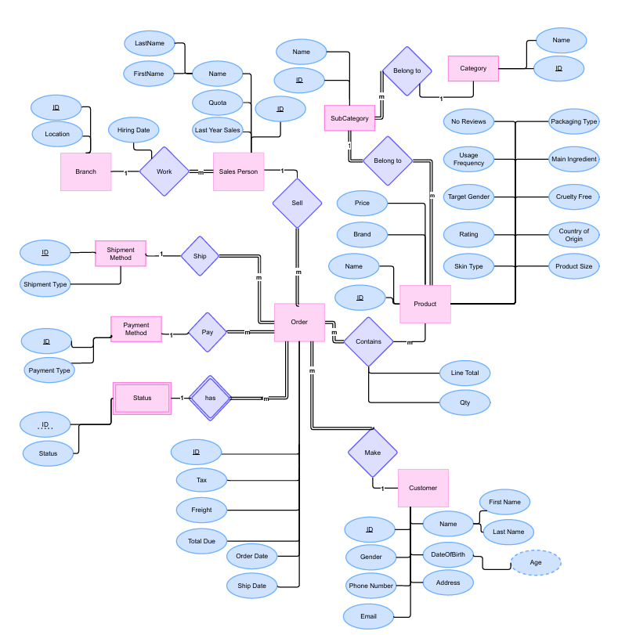

1 ERD

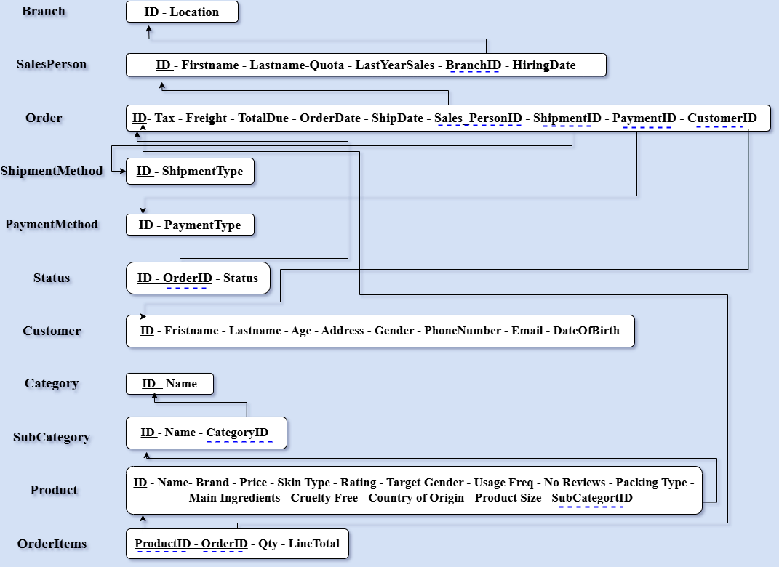

2 Mapping

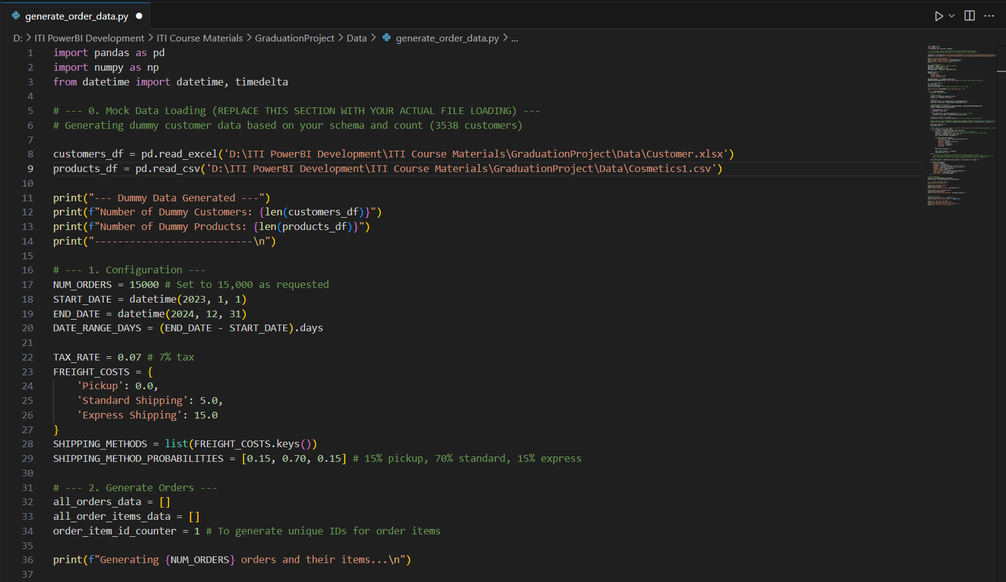

3 Data Generate

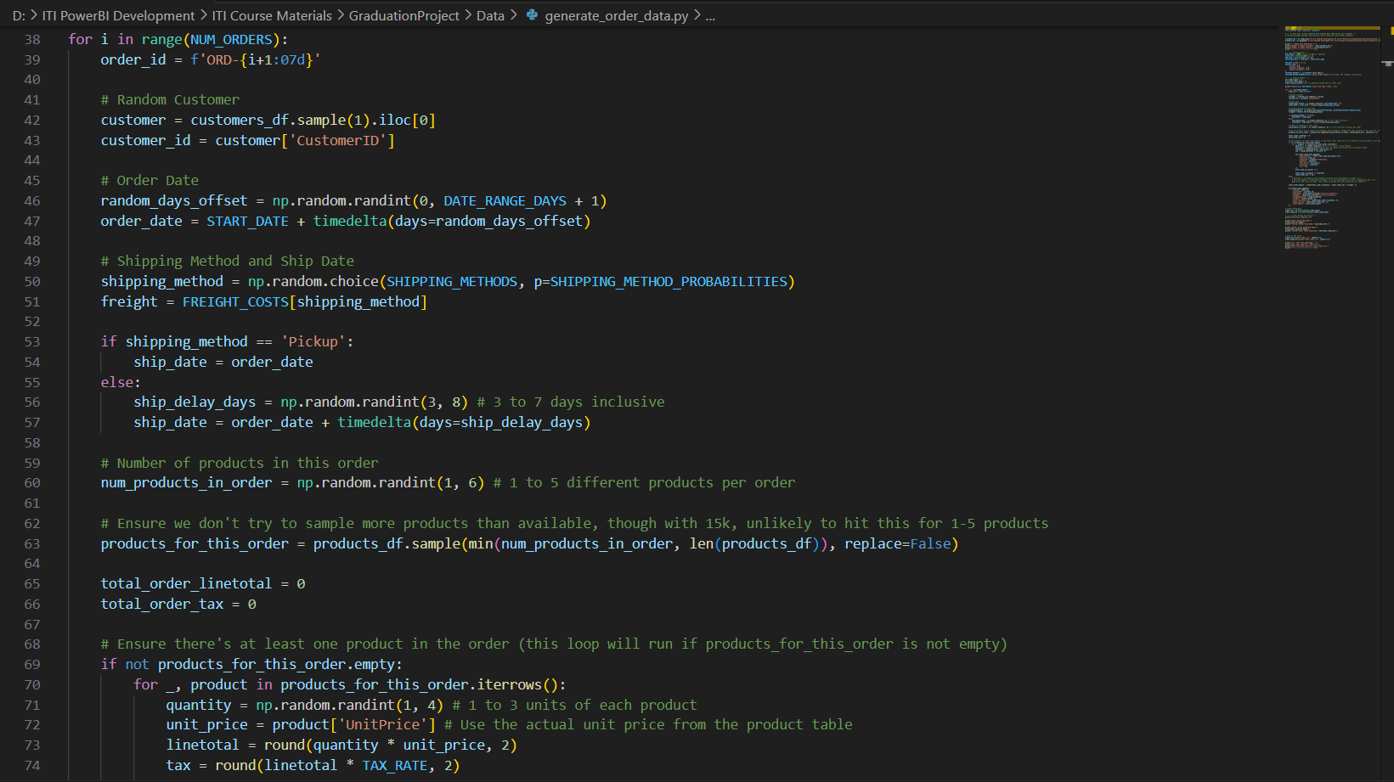

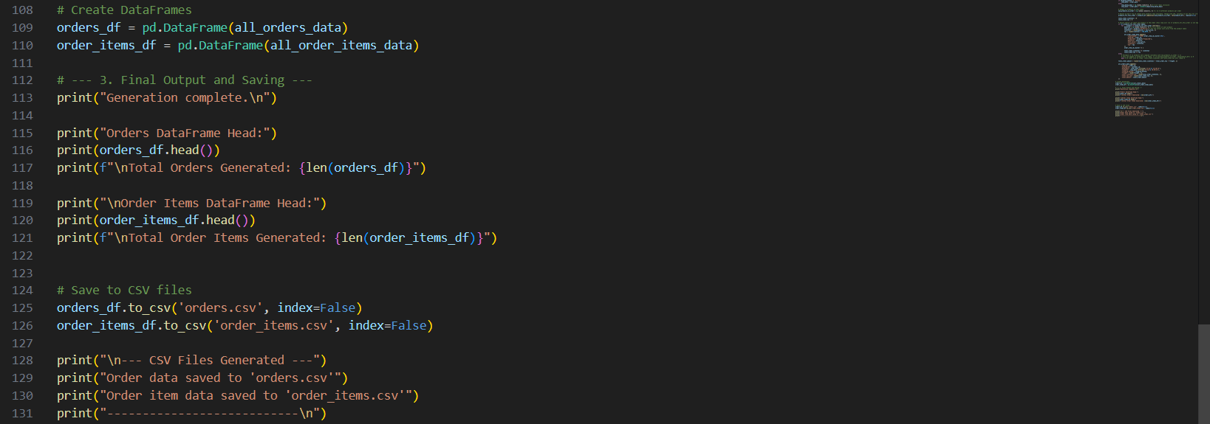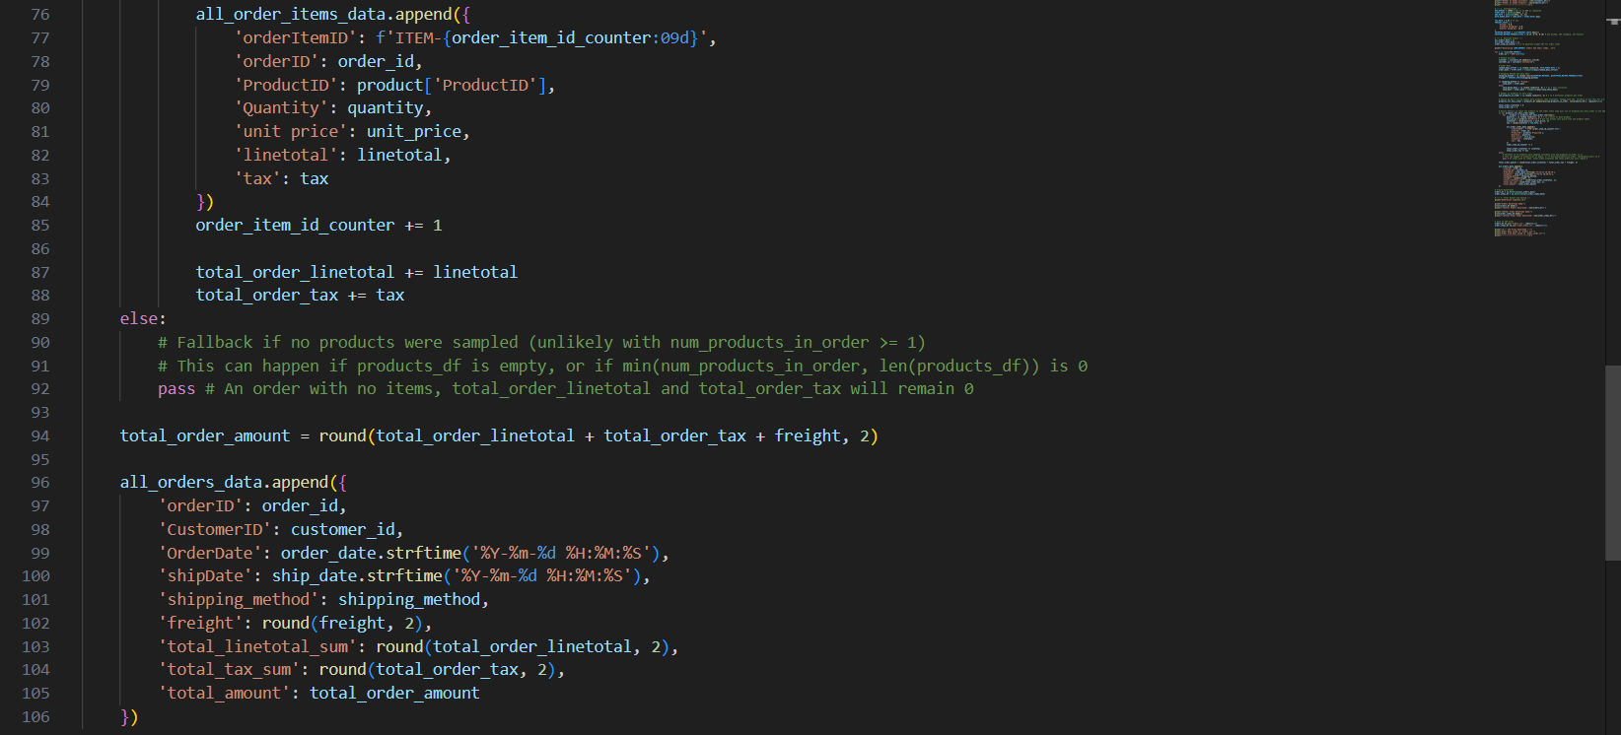

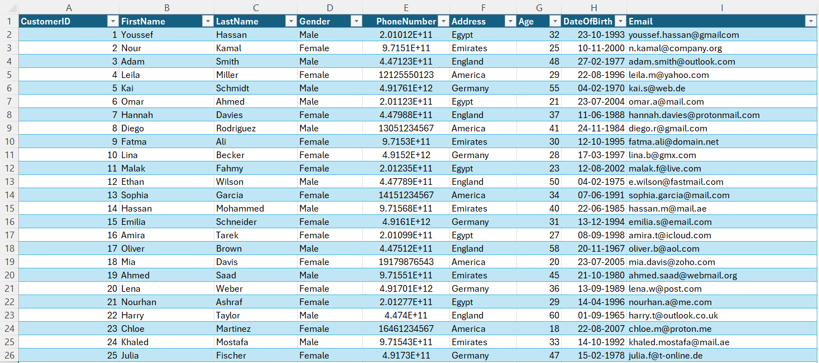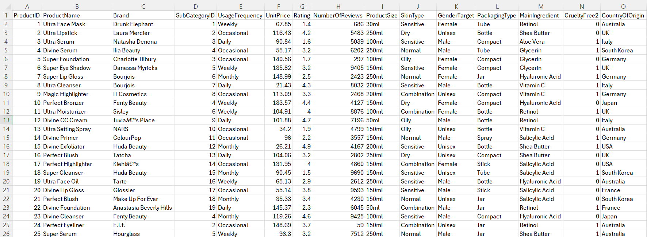

4 Data Collecting & Cleaning

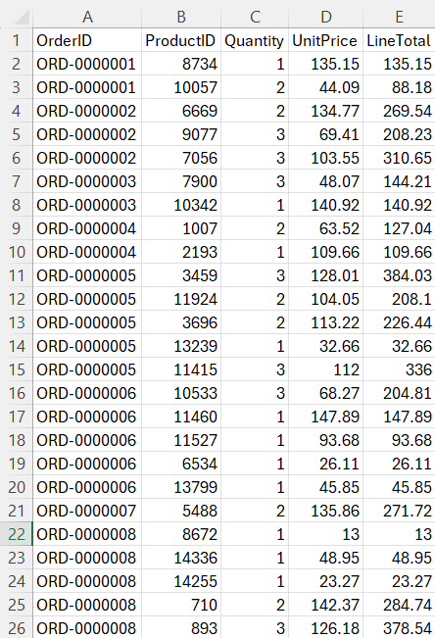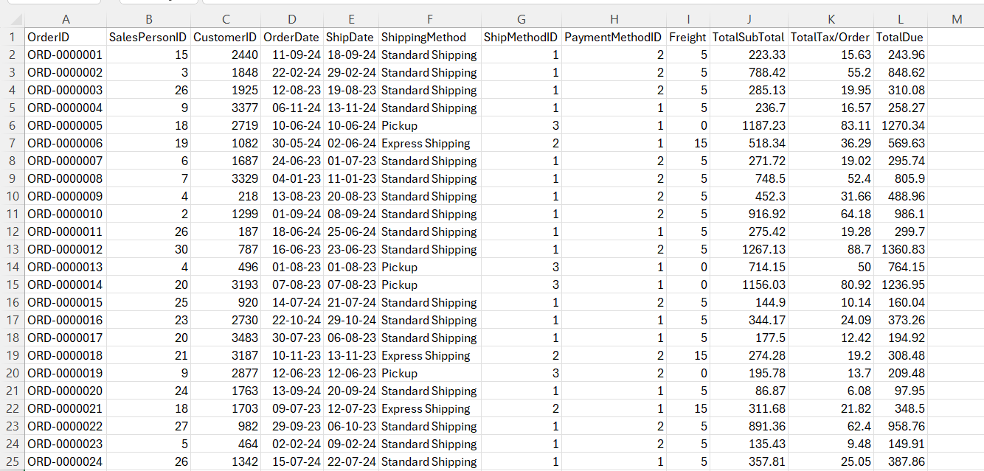

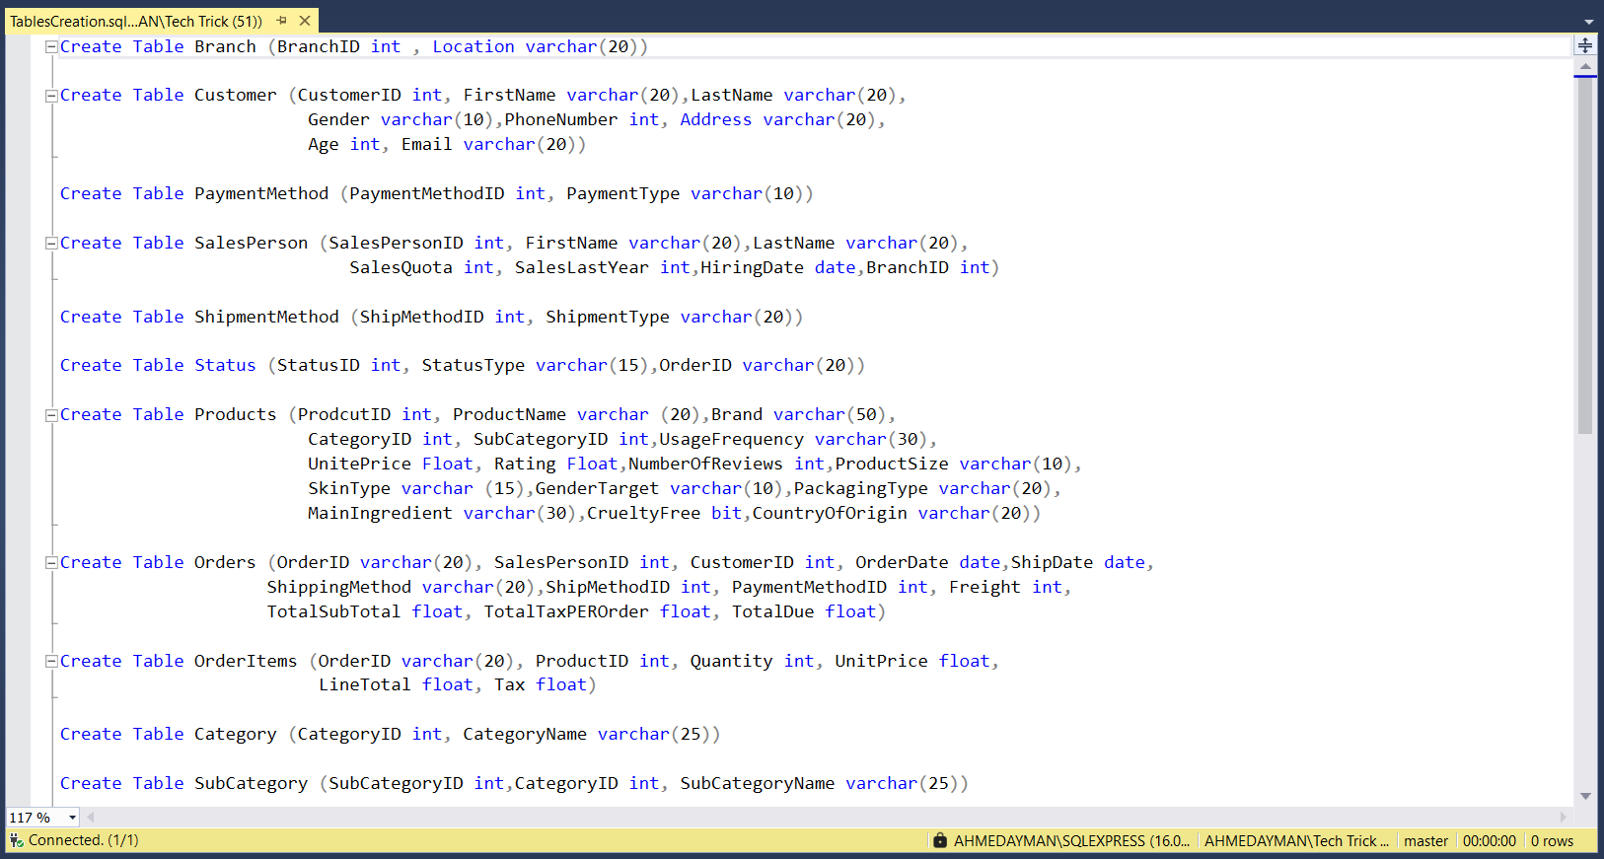

5 Tables Creation

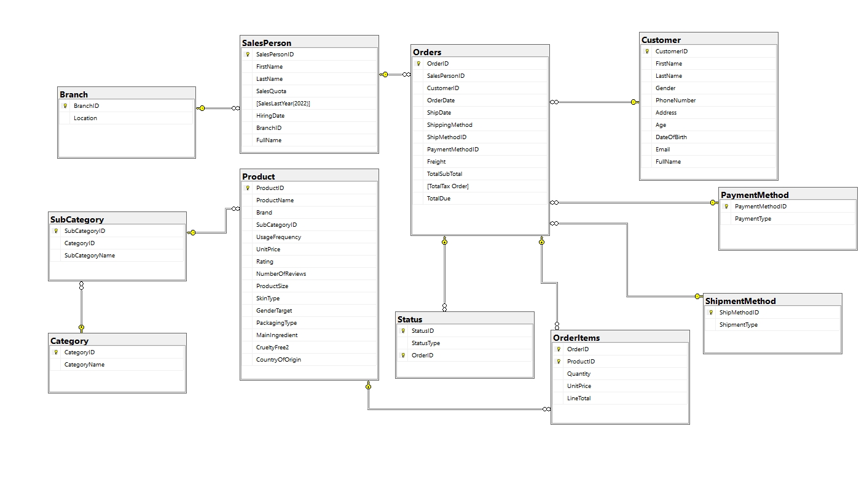

6 Relational Database Schema

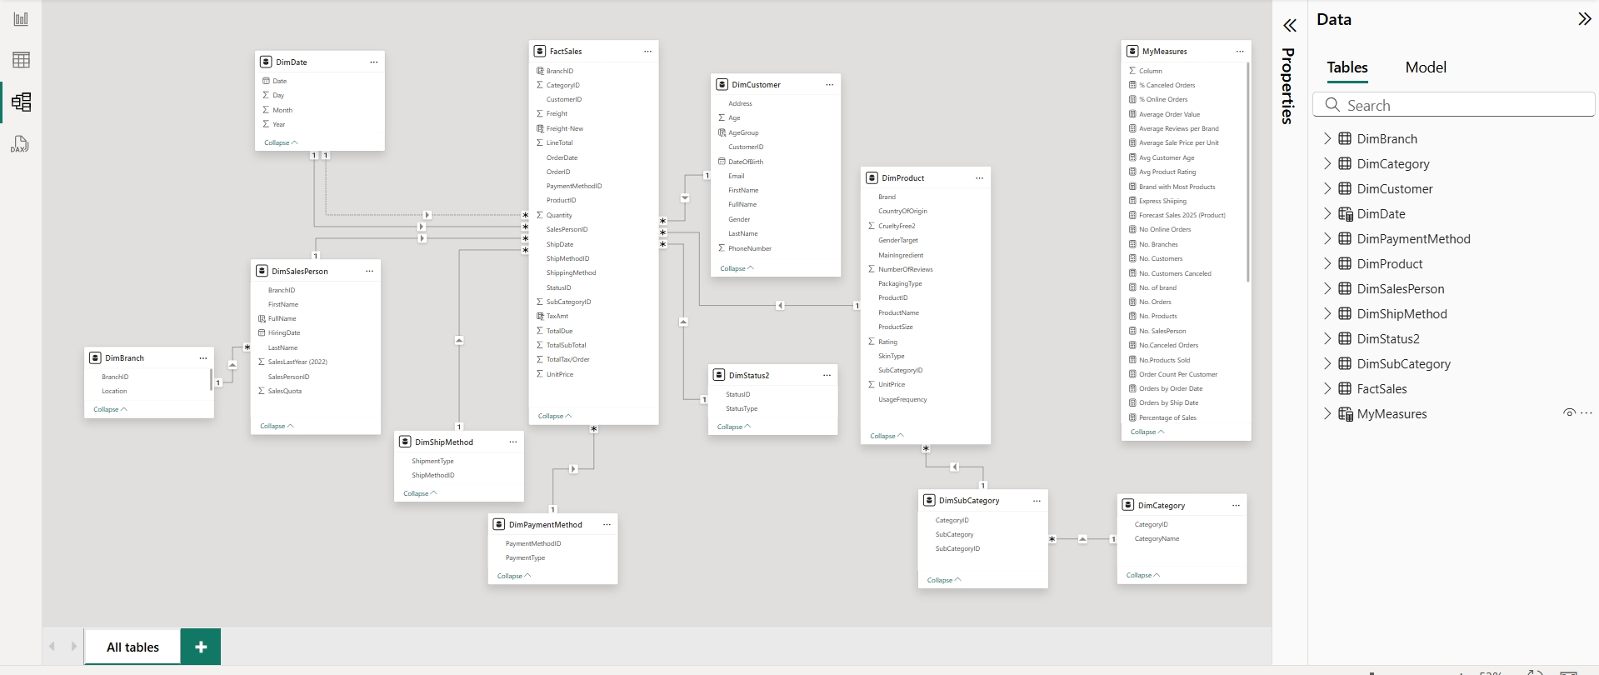

7 DWH Modeling in PowerBI

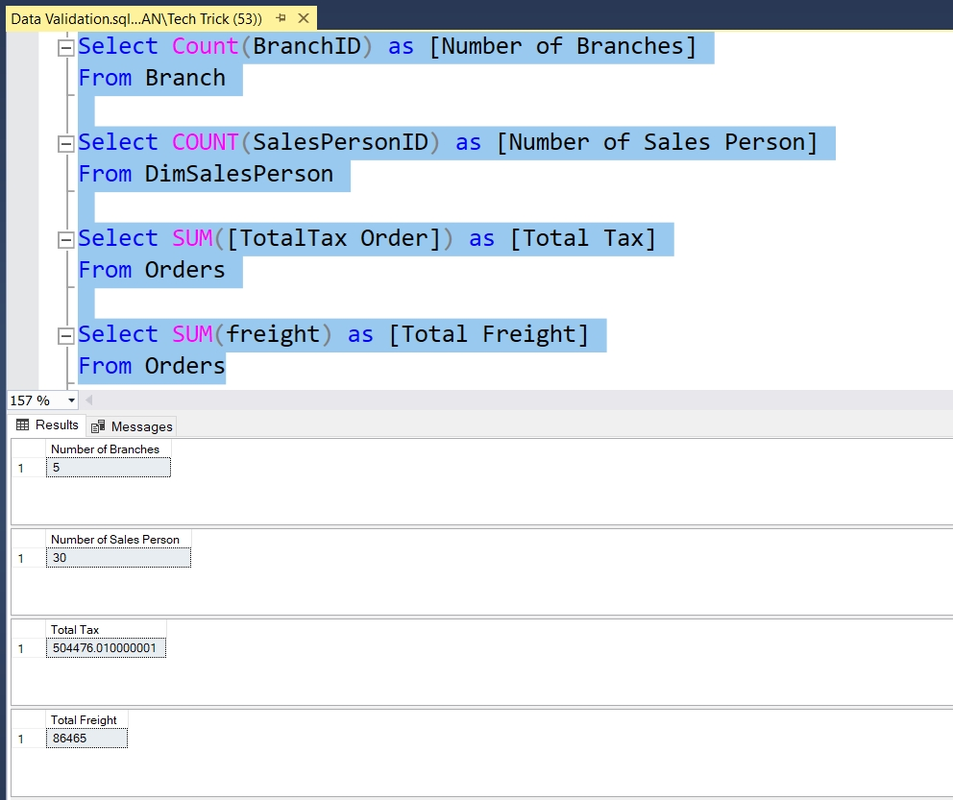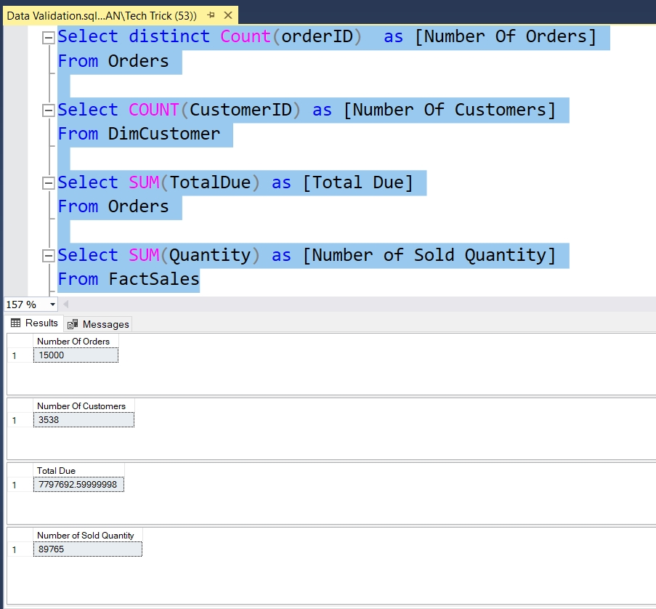Appendix B: Data Validation

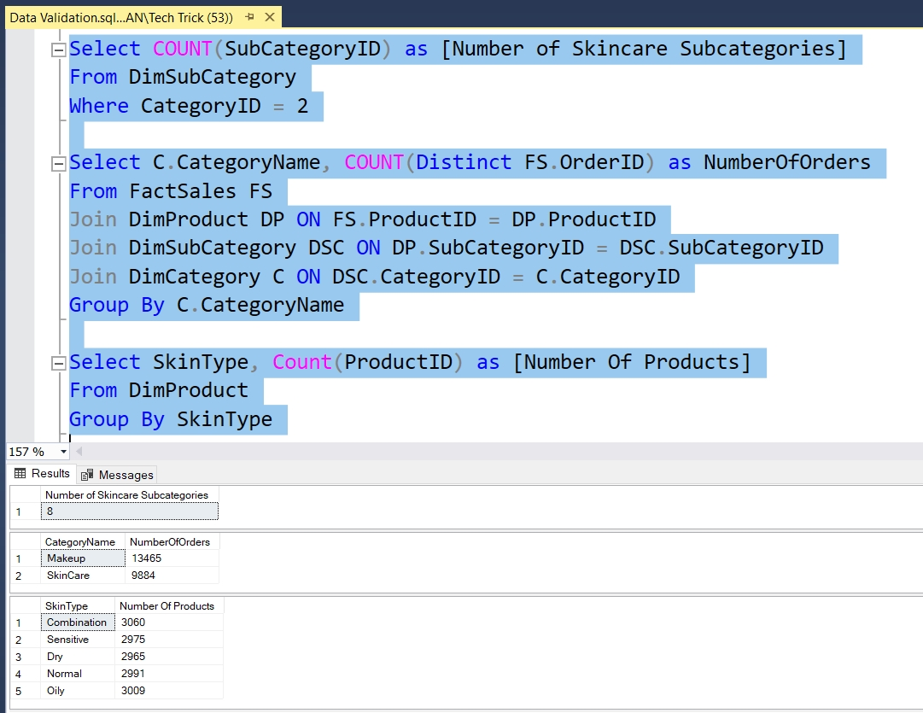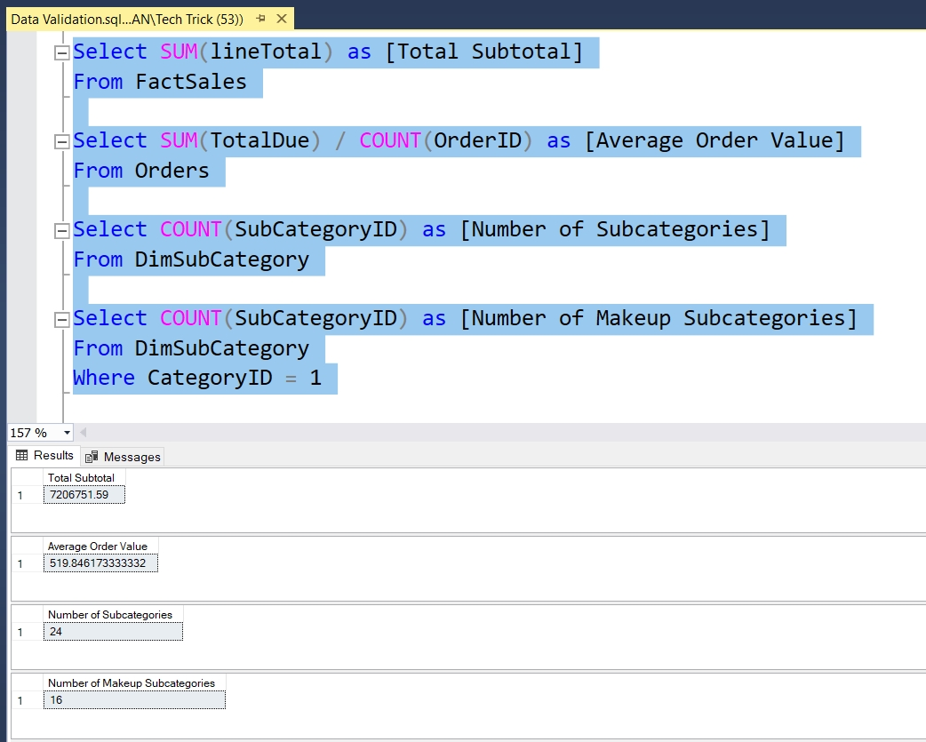

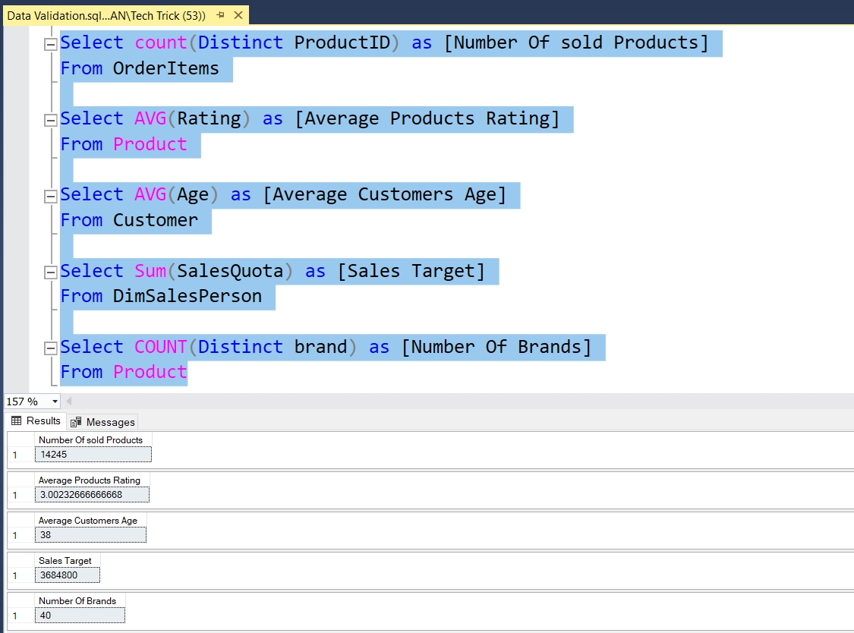

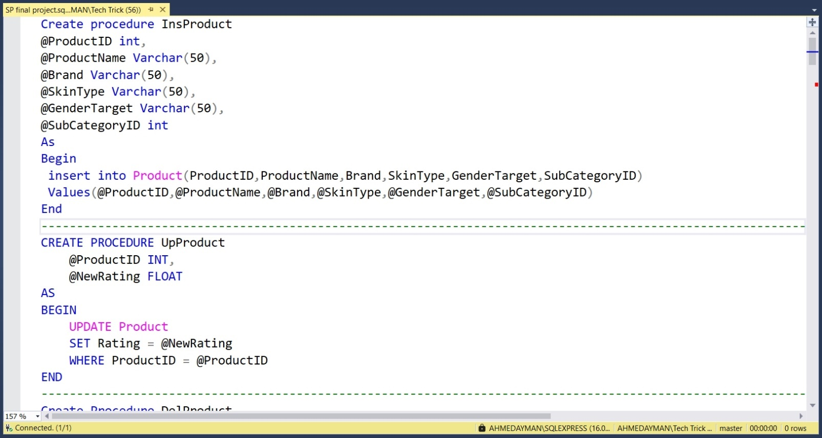**Appendix C Stored Procedures Creation**

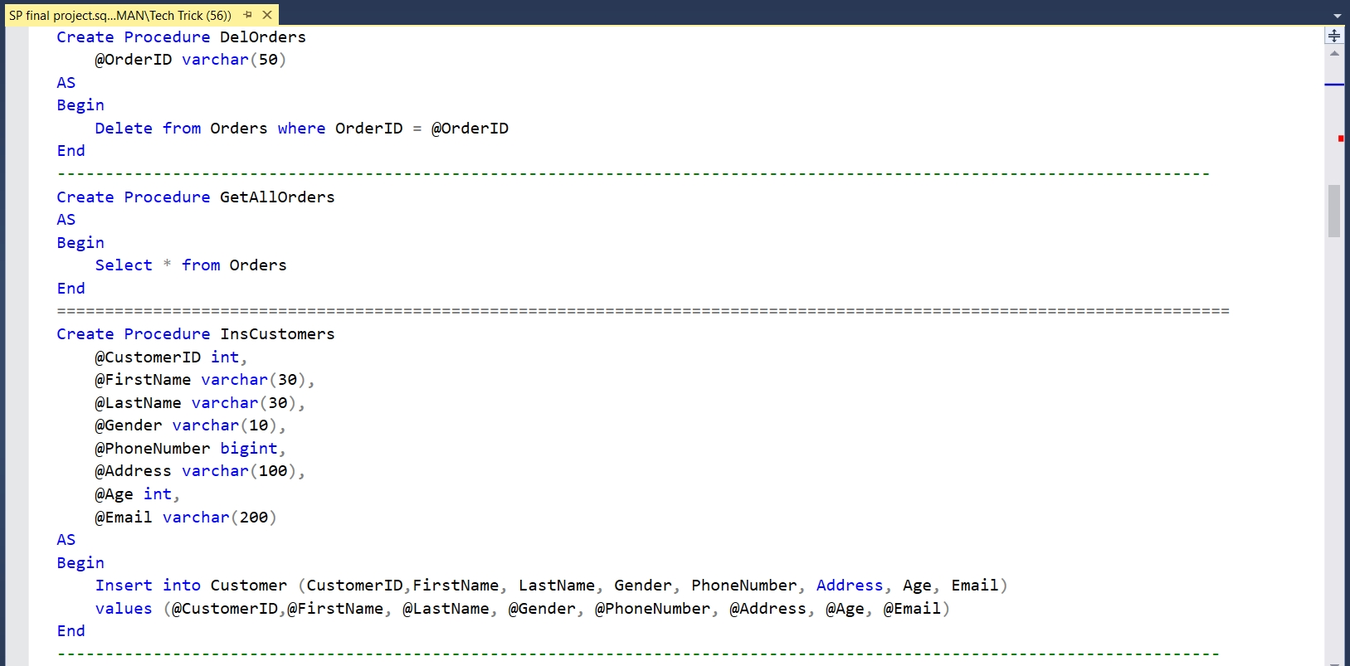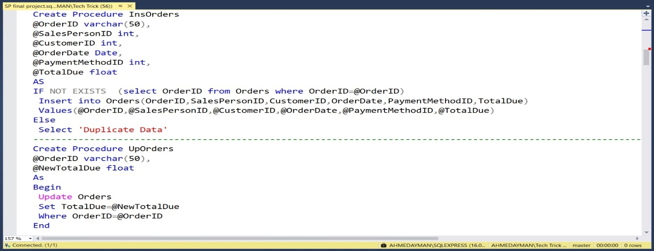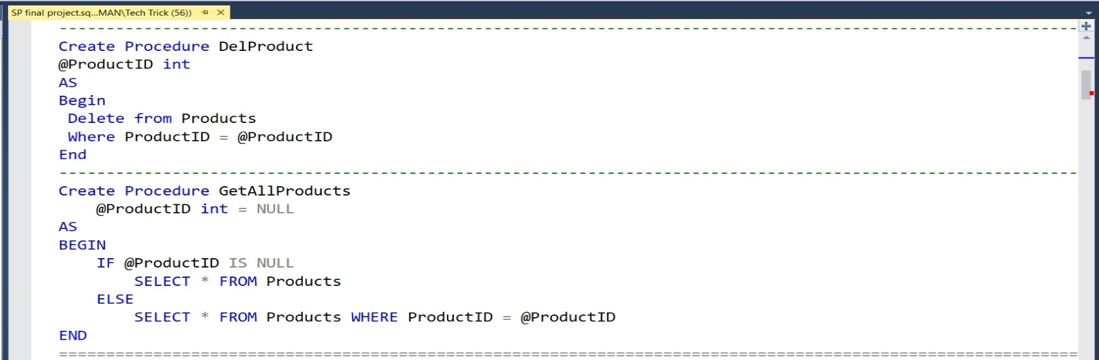

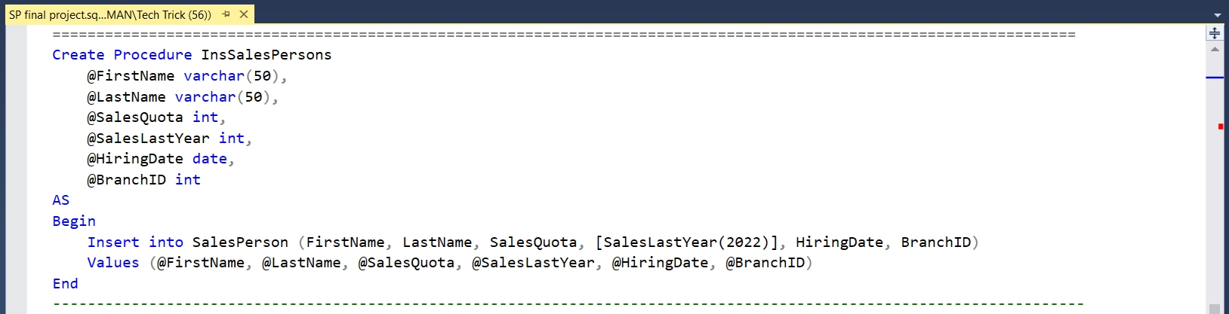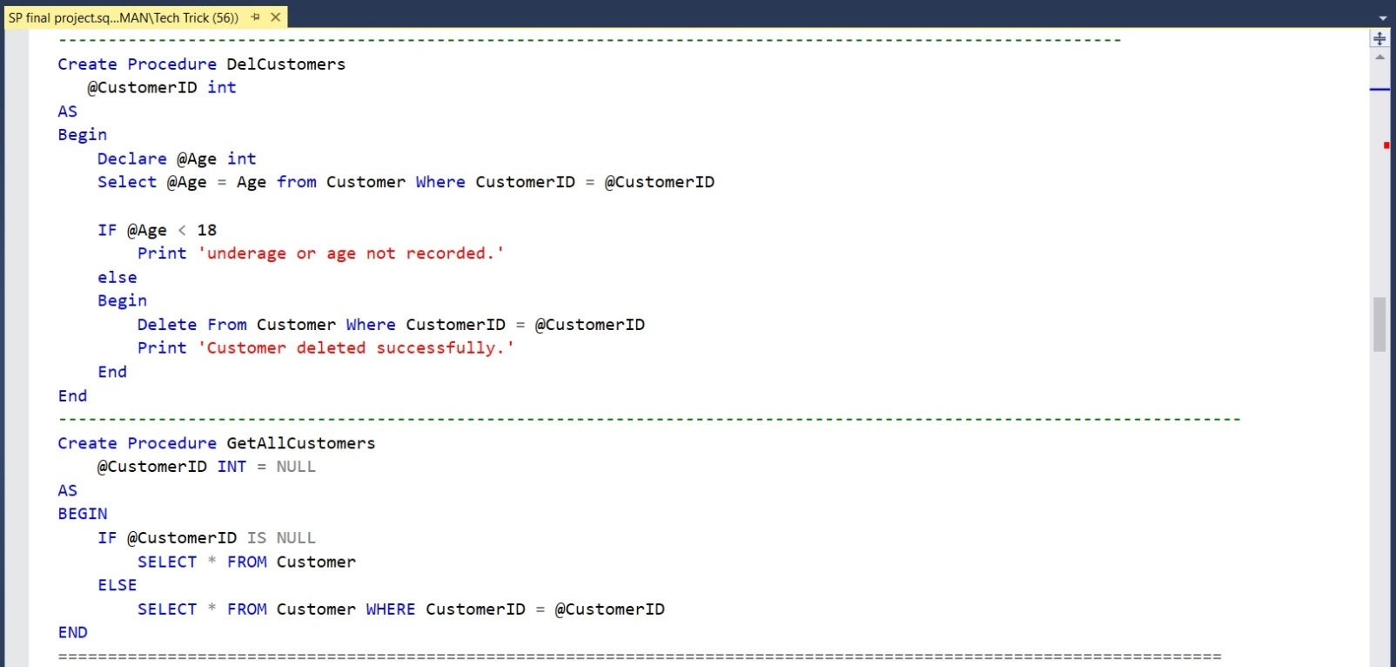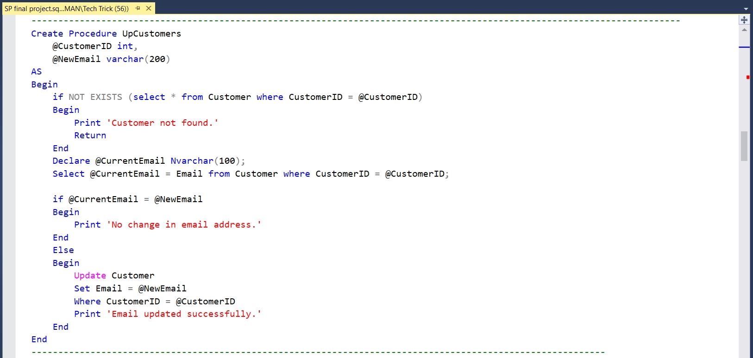

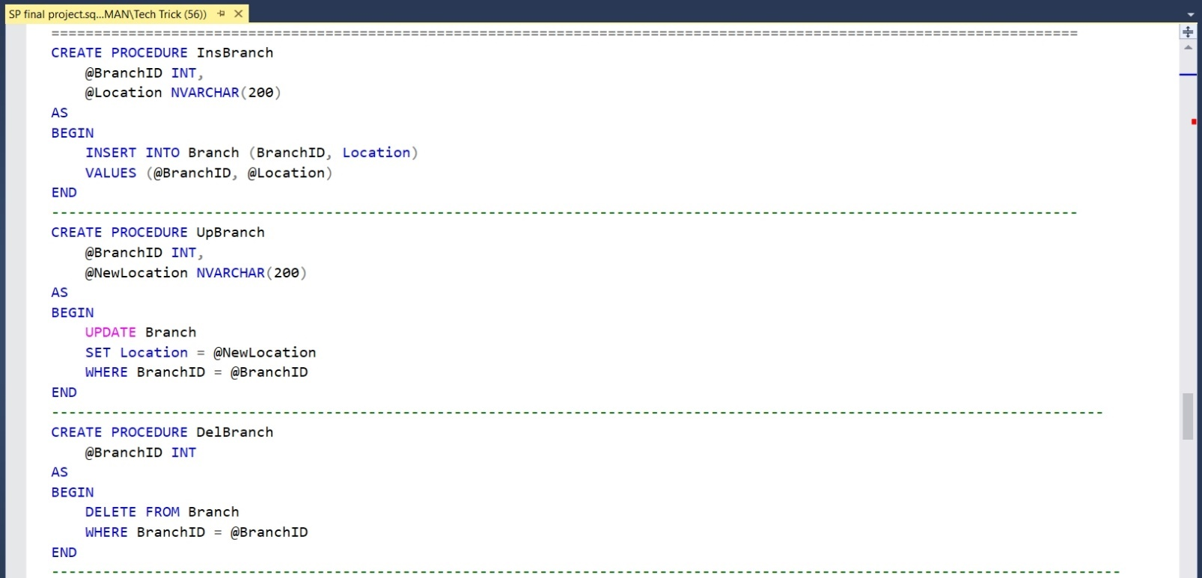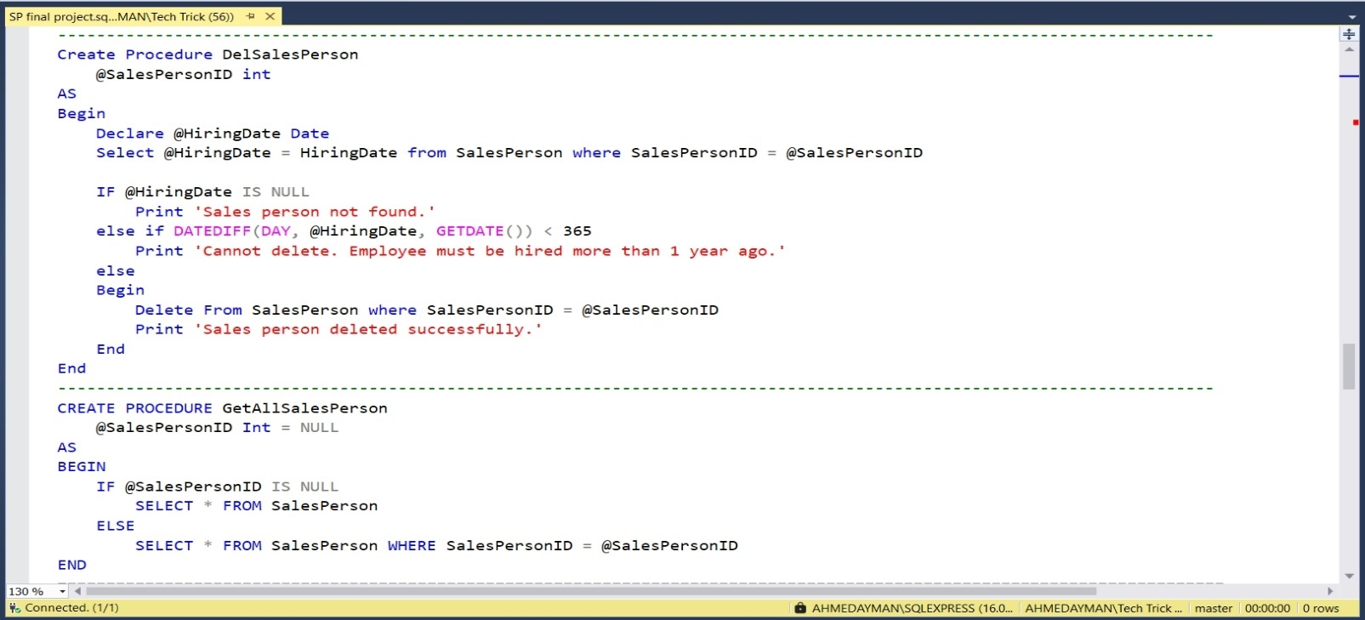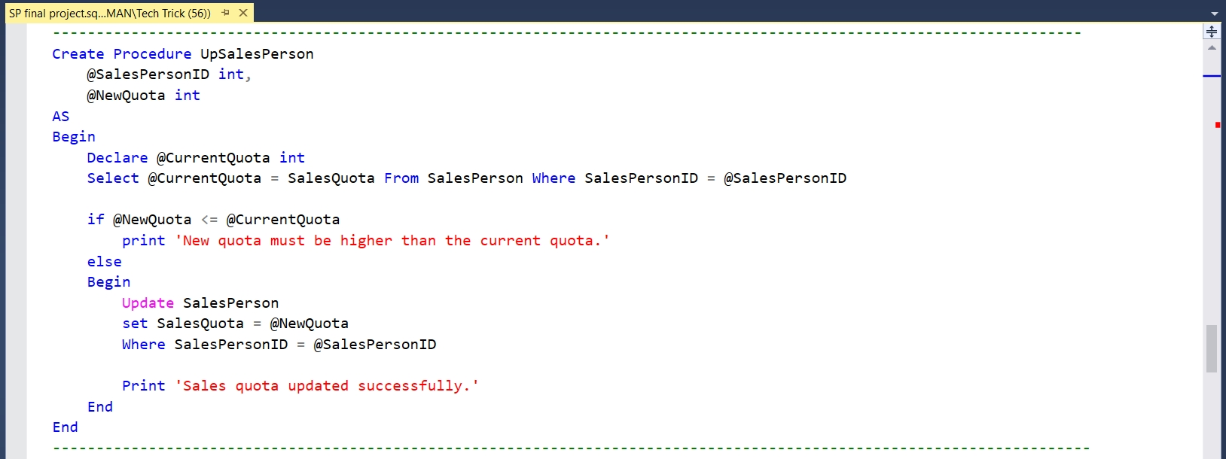

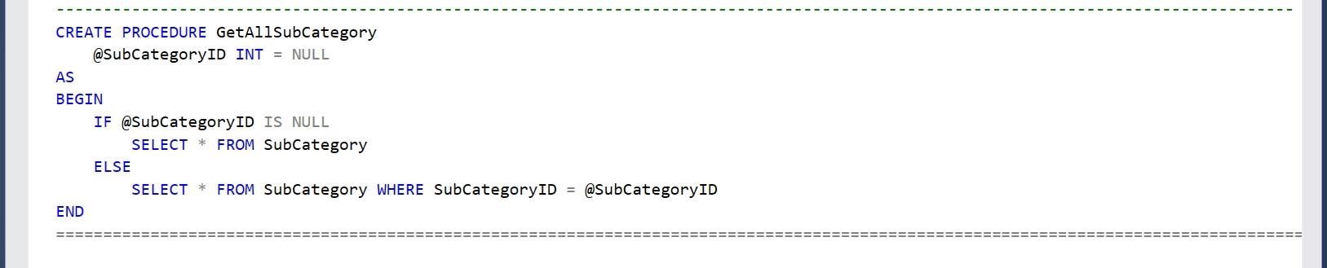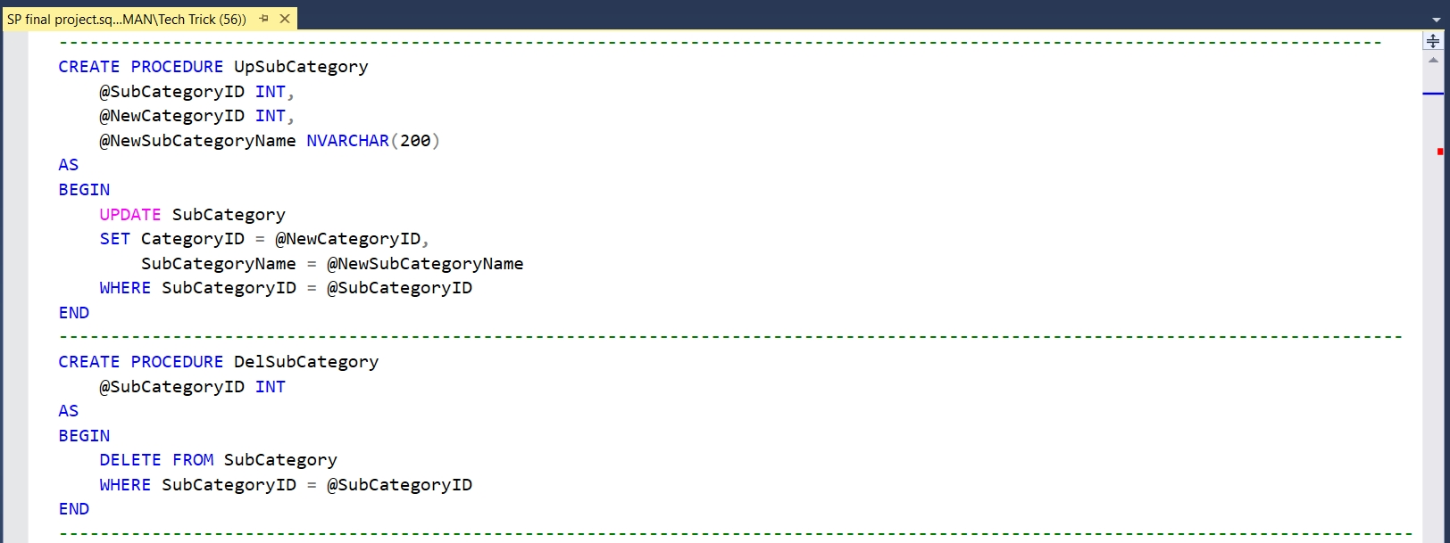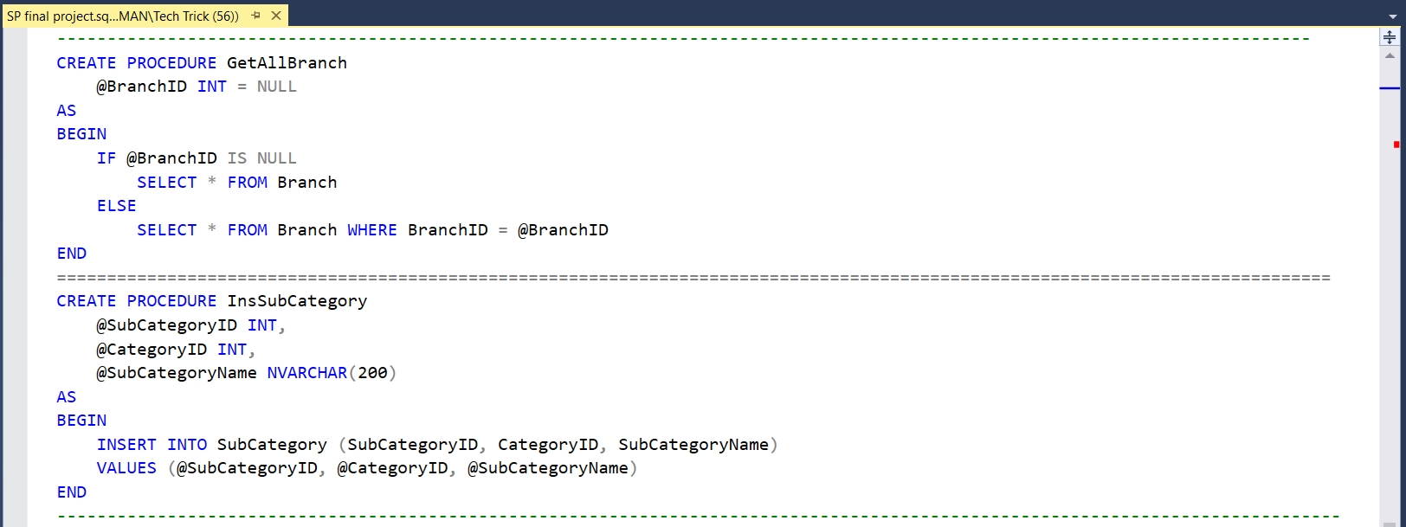

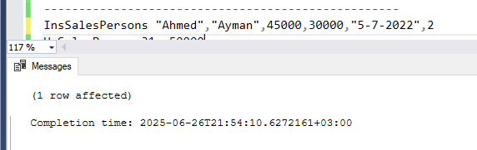**Appendix D Stored Procedures Execution**

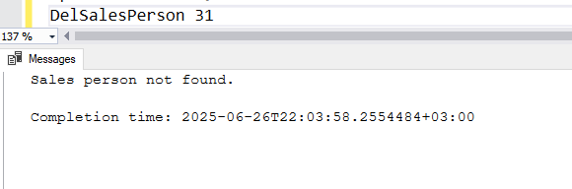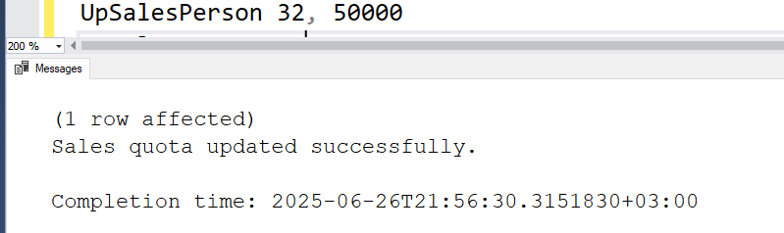

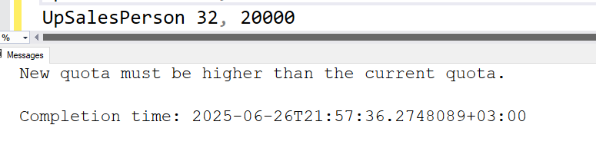

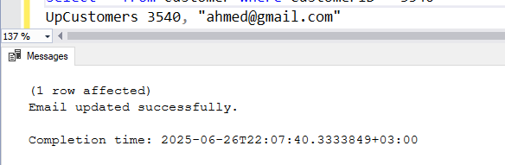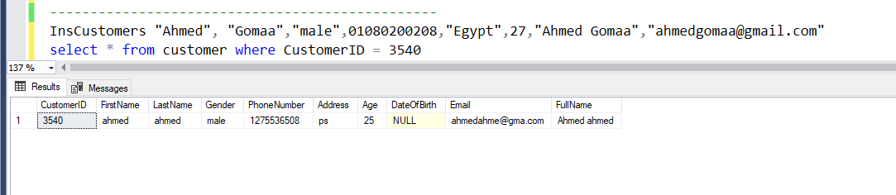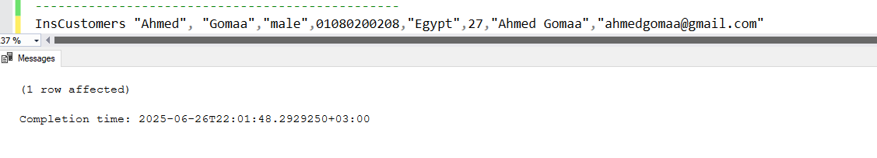

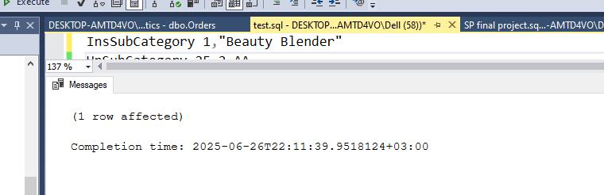

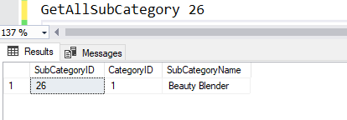

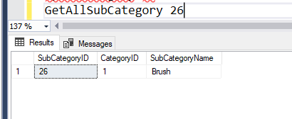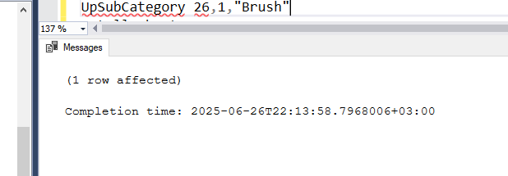

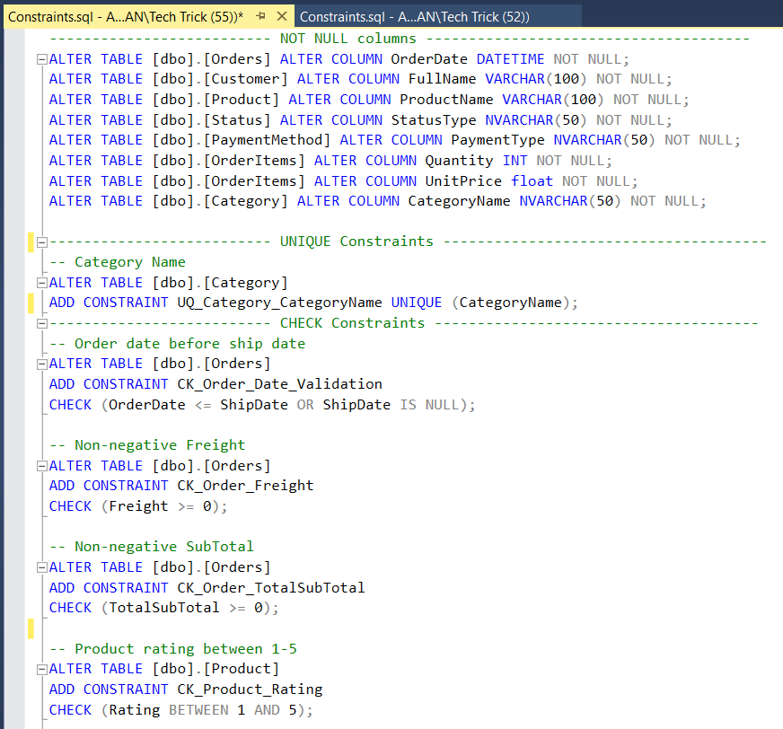**Appendix E Constraints**

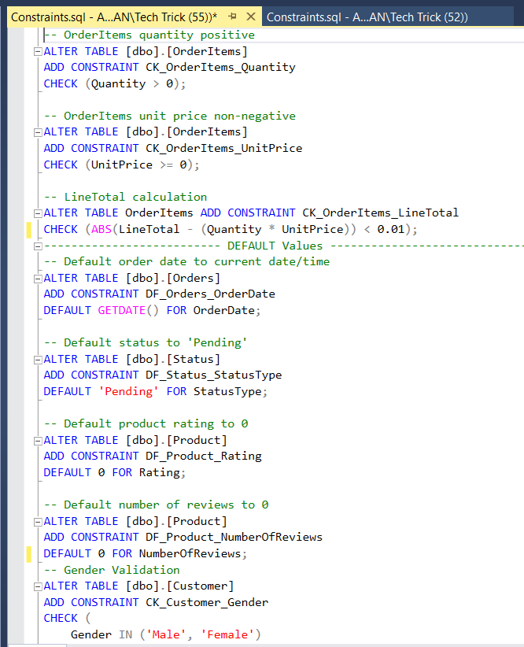

Appendix F: SQL Server Integration Services (SSIS) DB

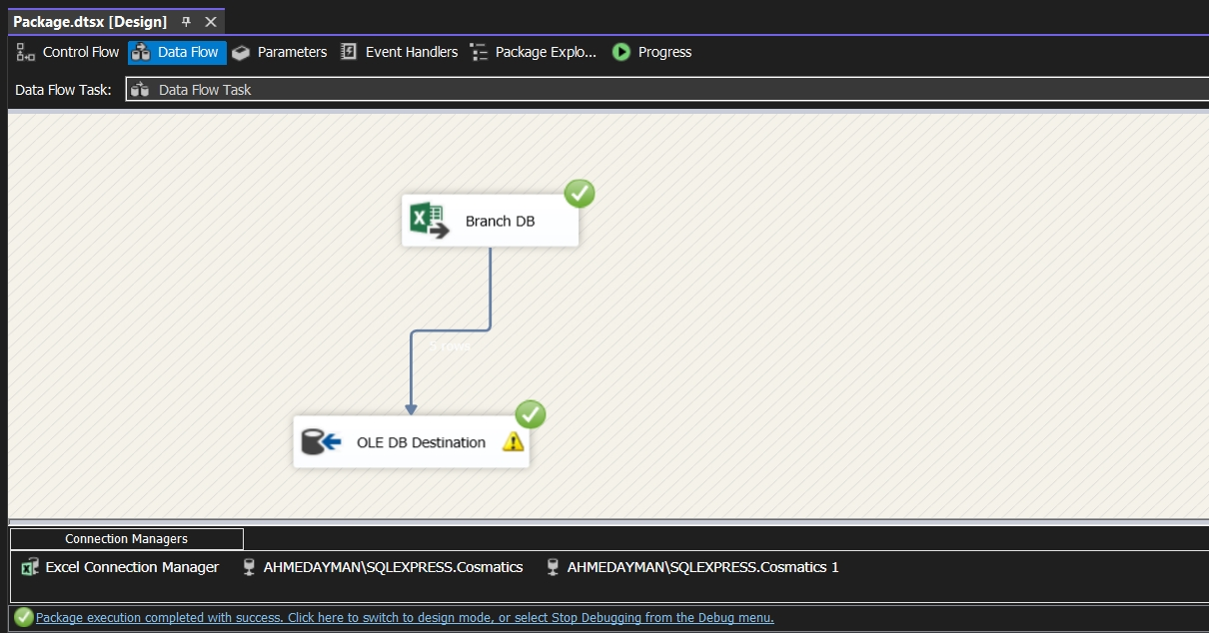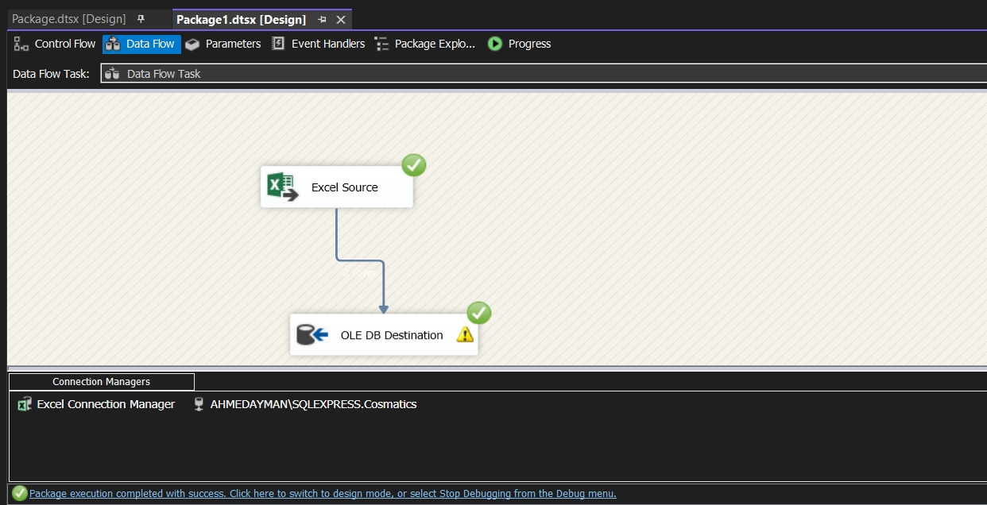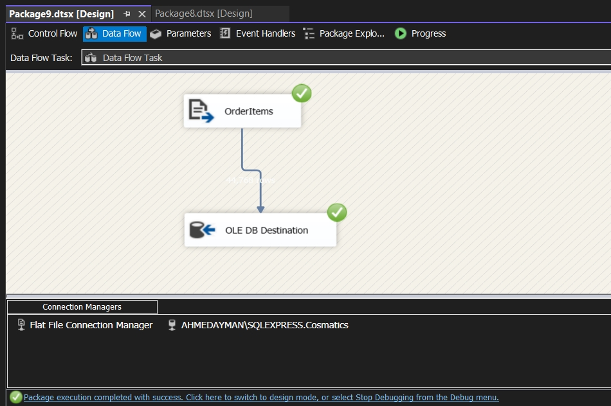

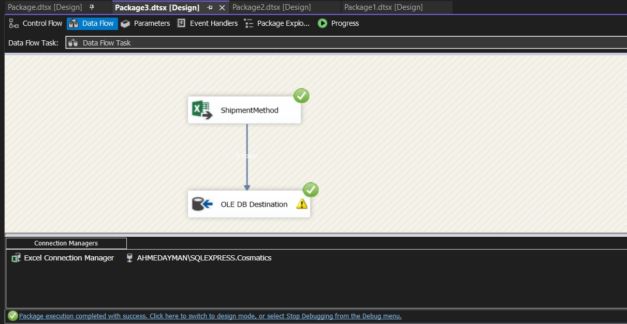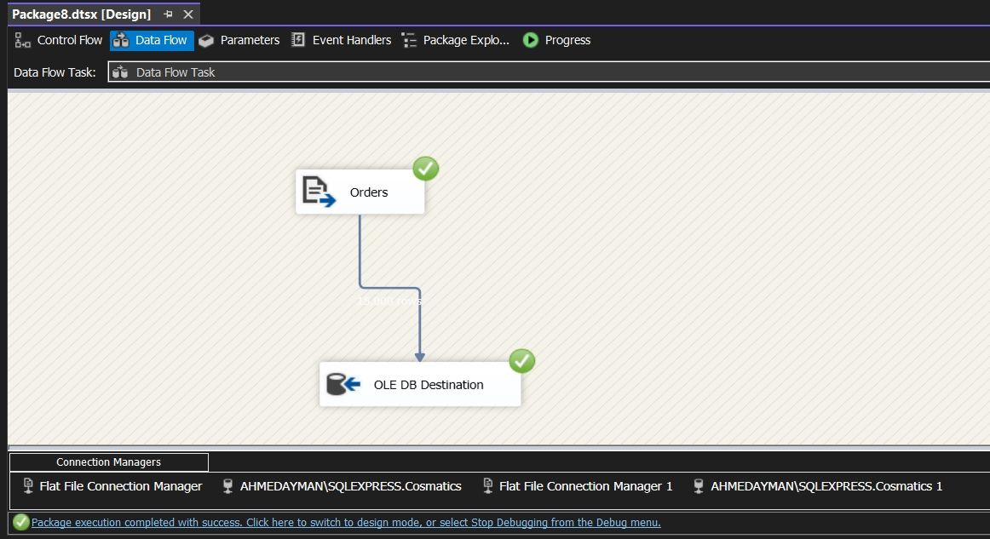

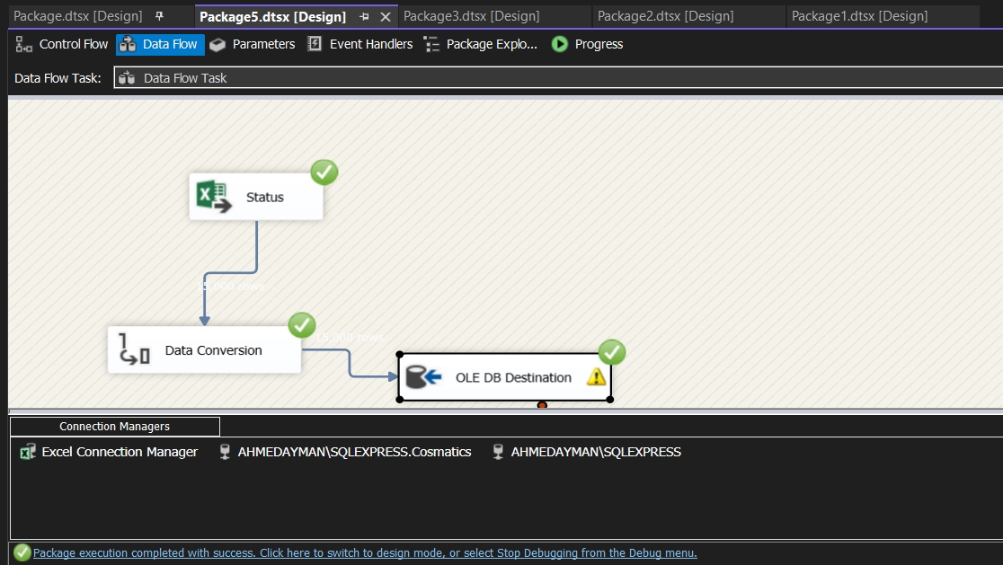

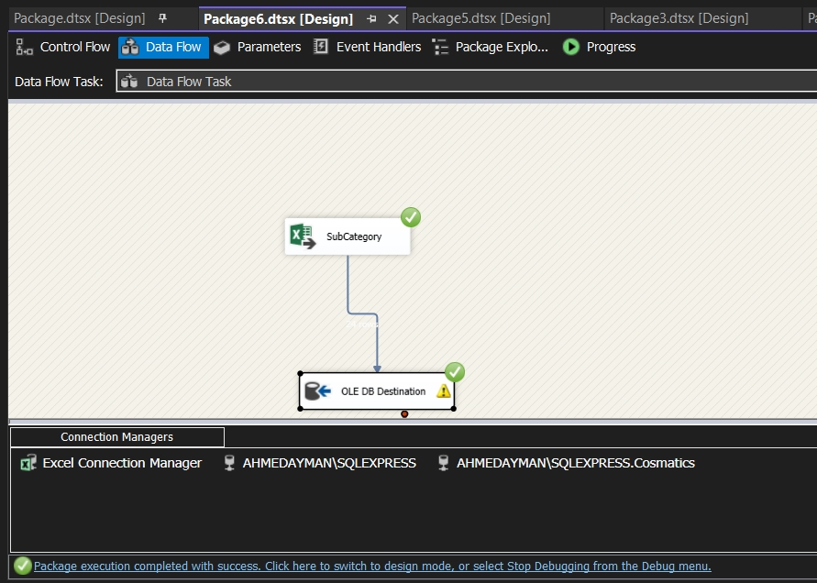

**SQL Server Integration Services (SSIS) DWH**

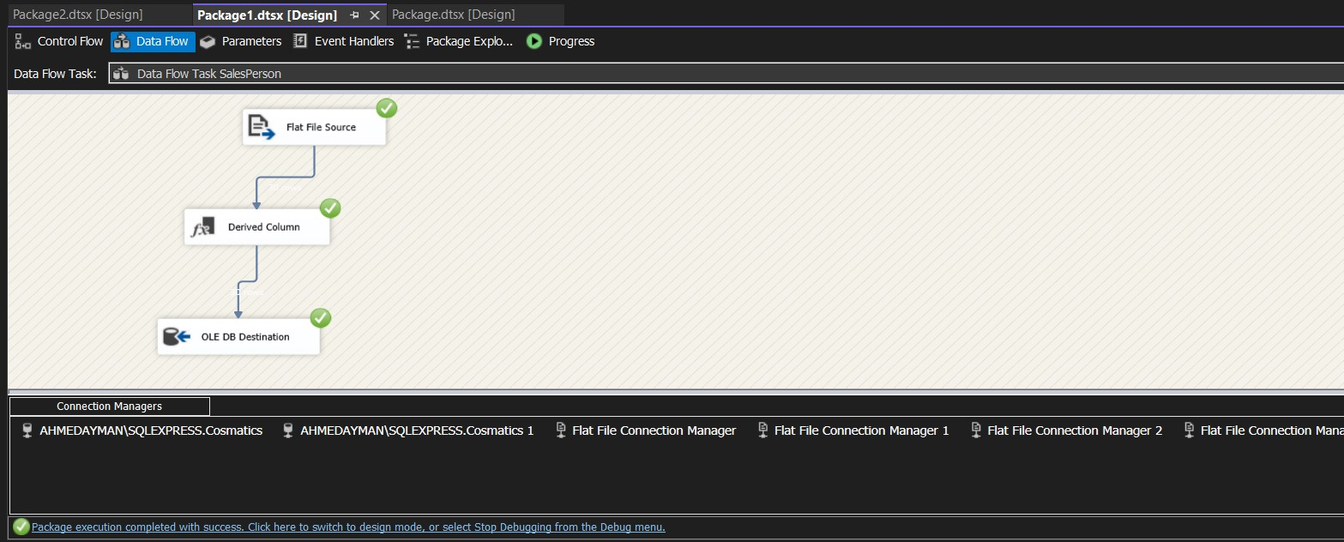

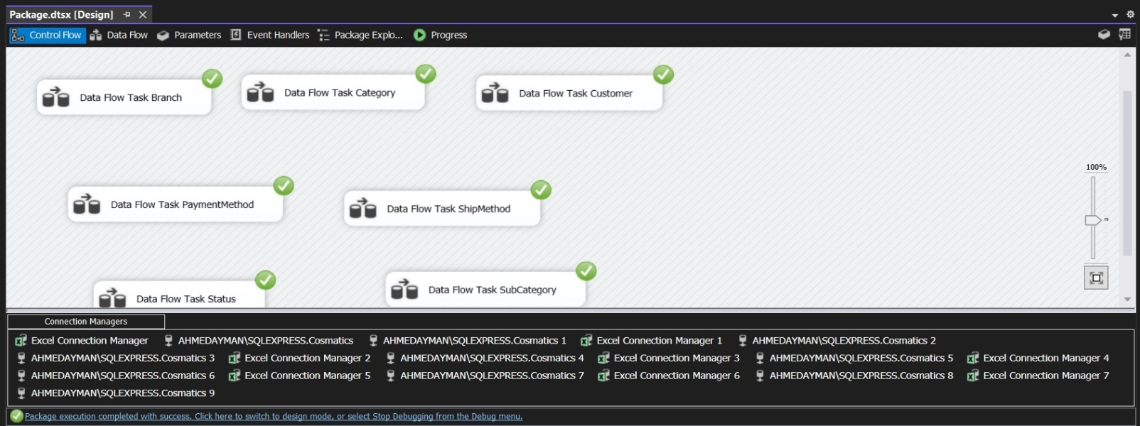

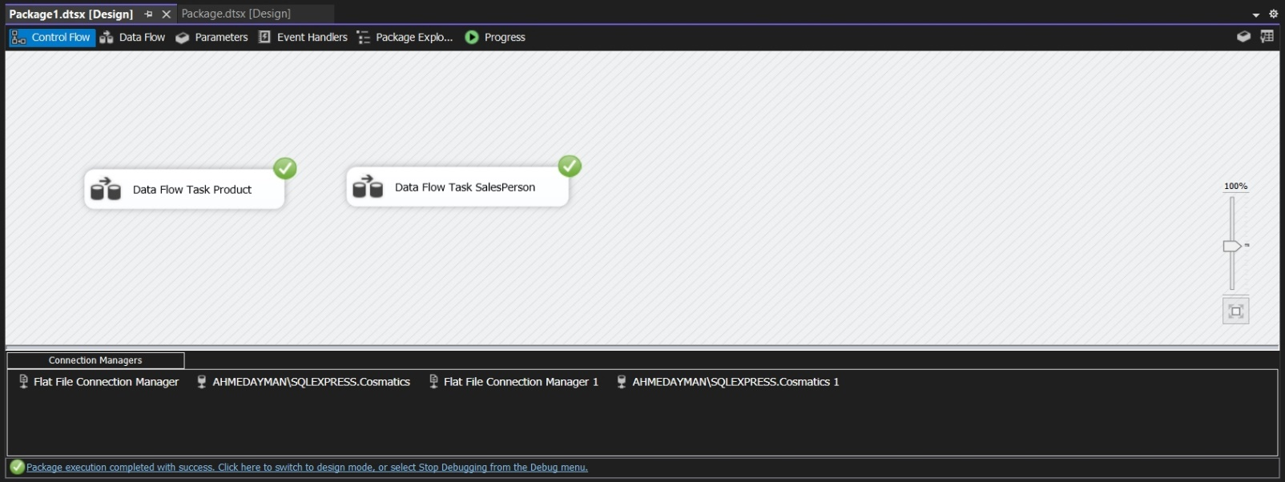

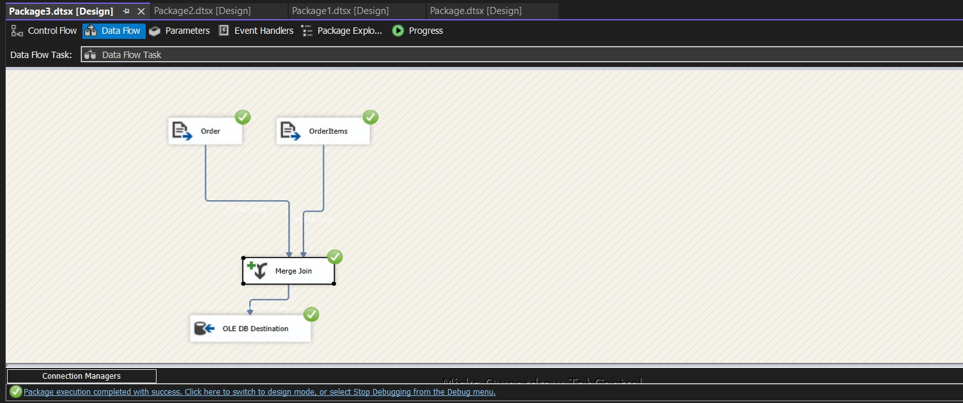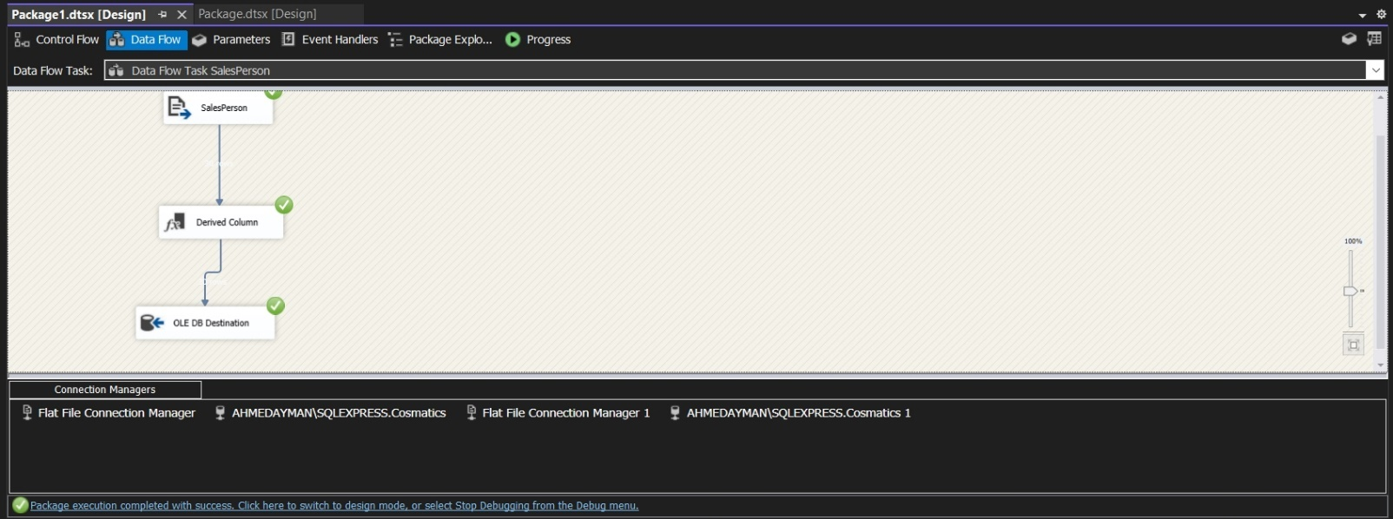

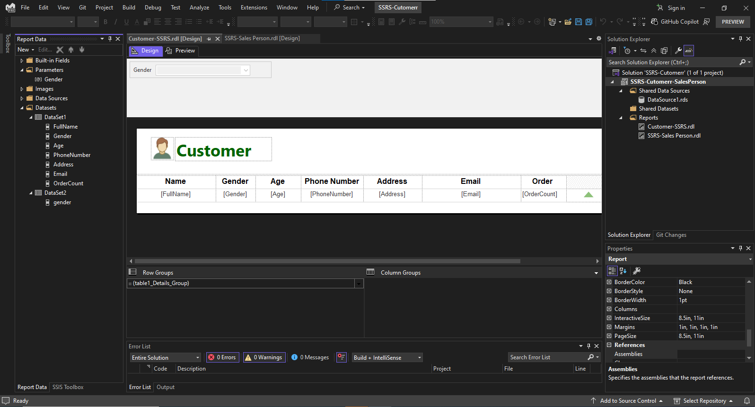Appendix G SQL Server Reporting Services (SSRS)

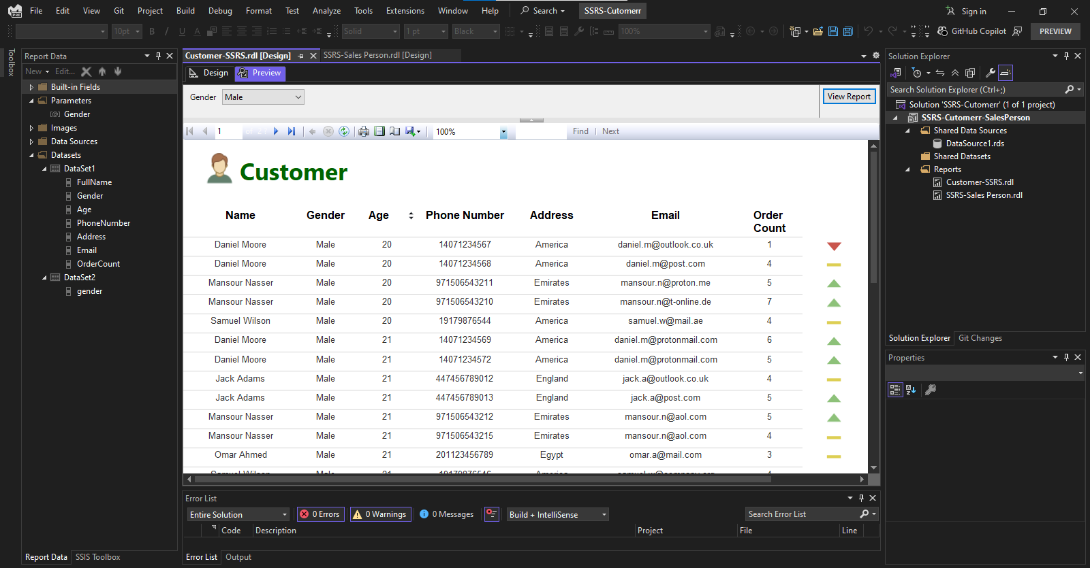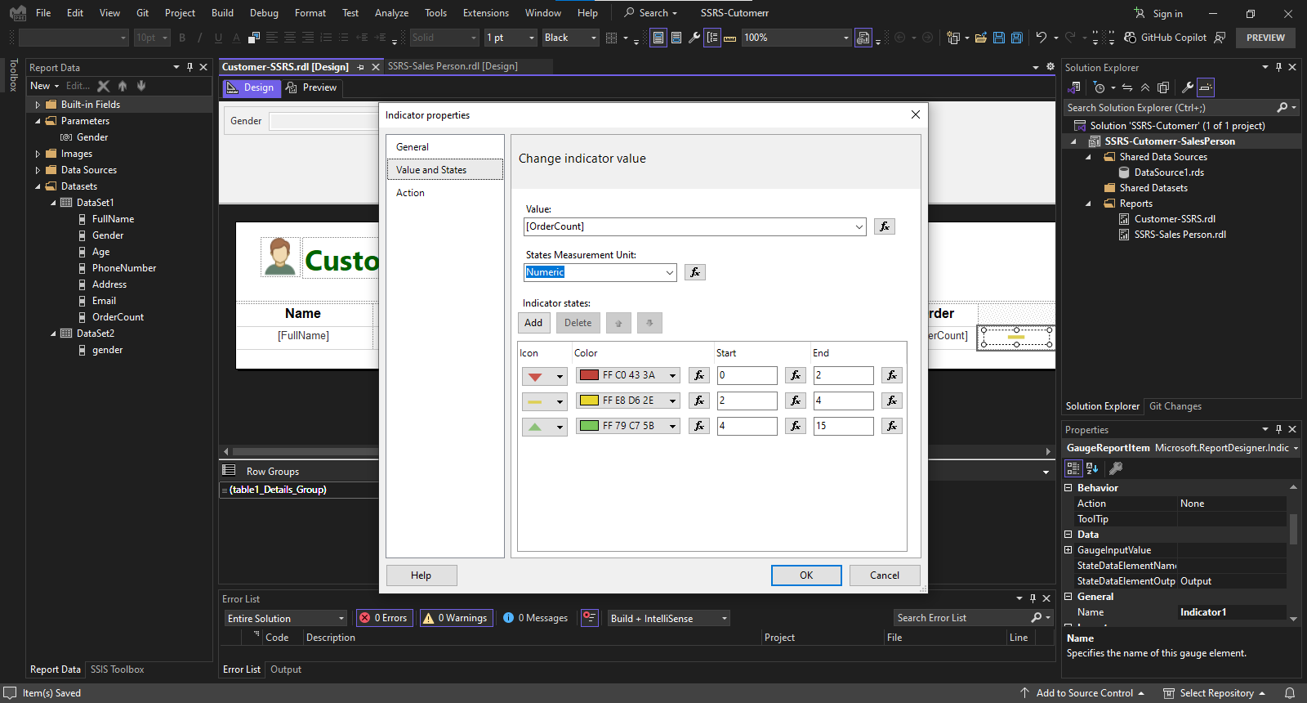

8 Customer Report

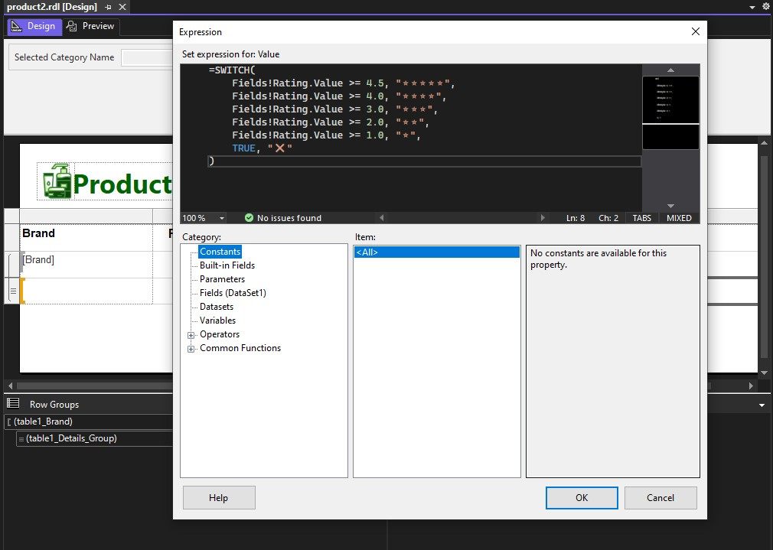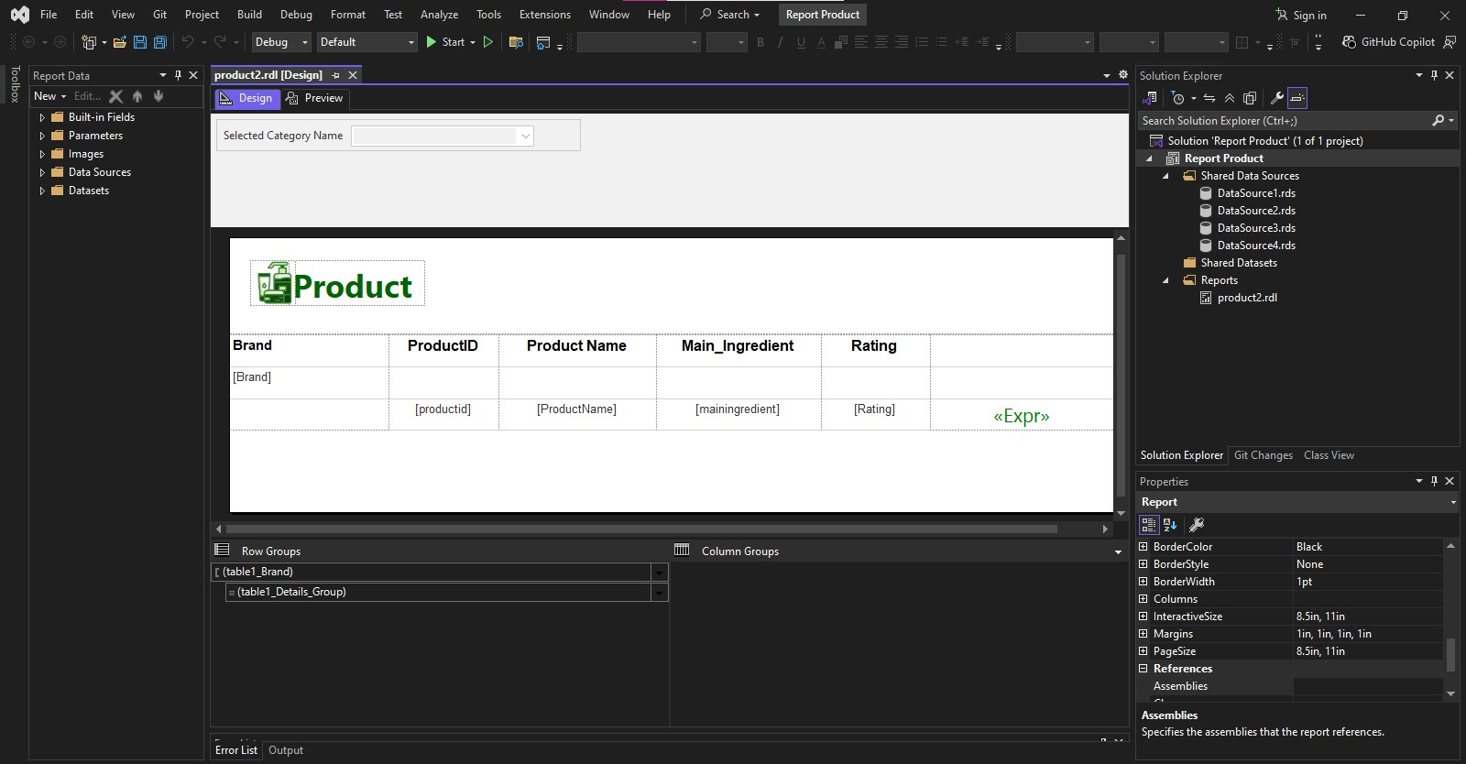

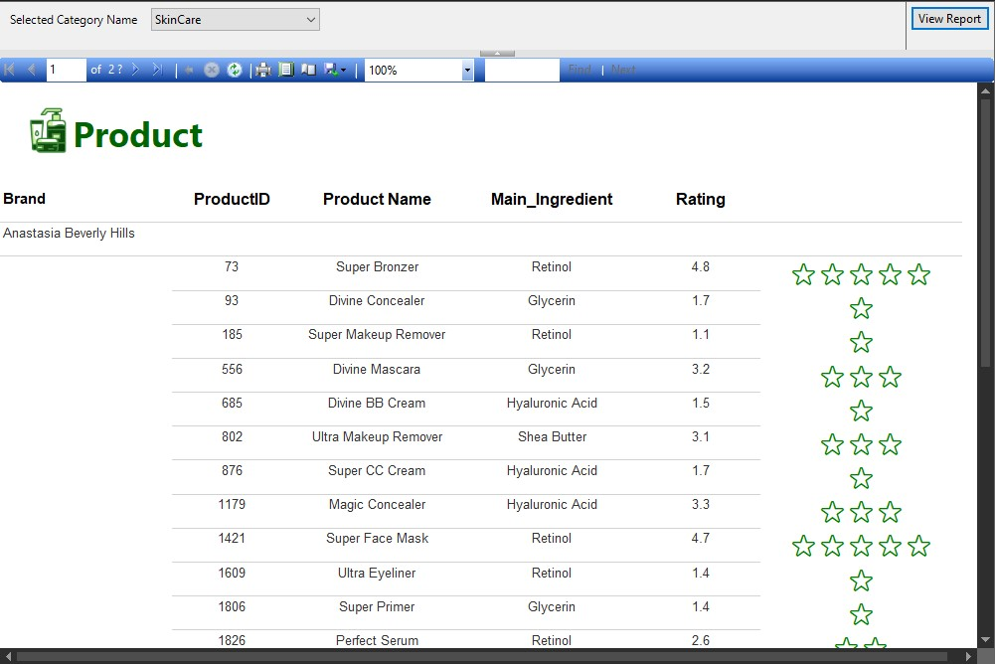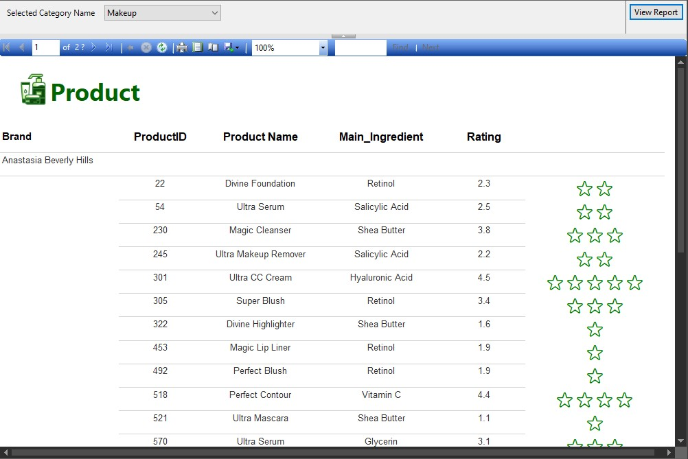

9 Product Report (Makeup)

10 Product Report (SkinCare)

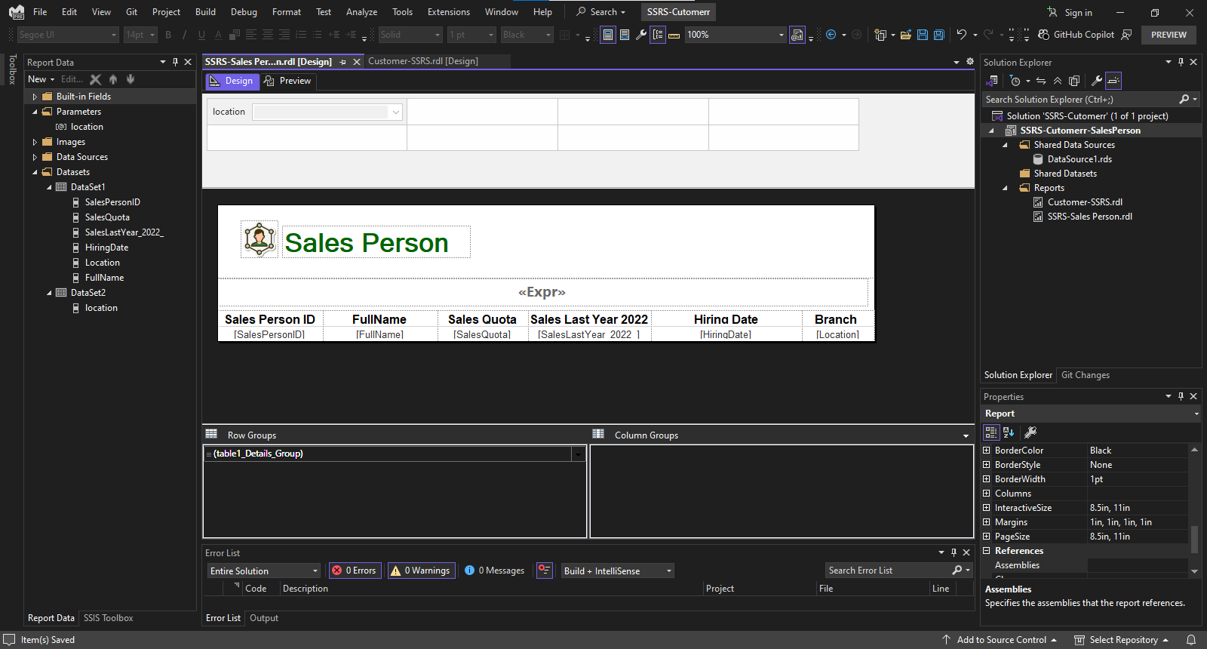

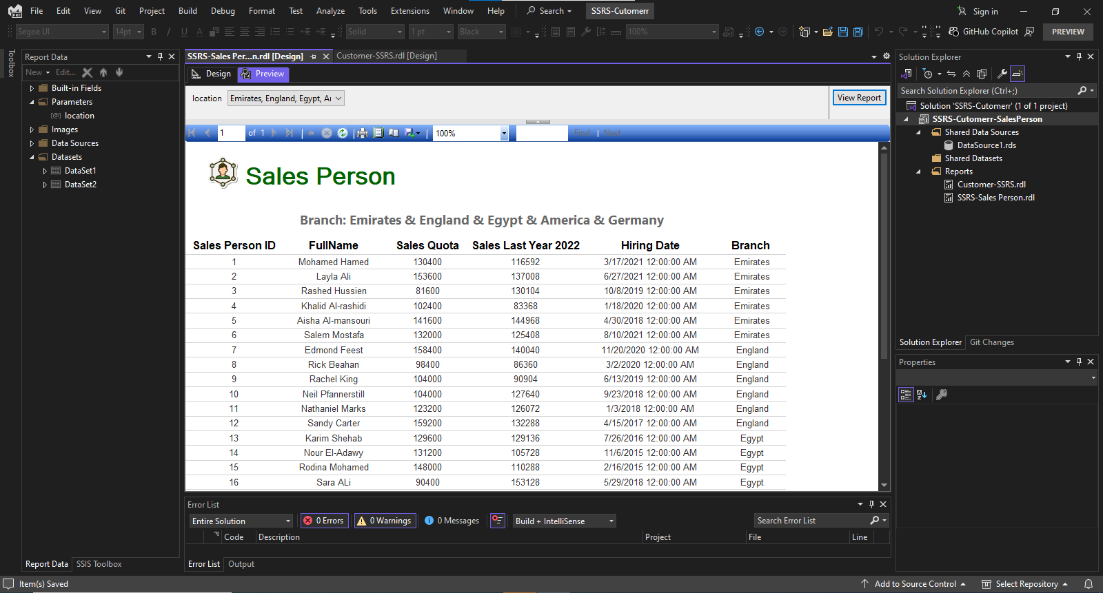

11 Salesperson Report

Appendix H Dashboards:

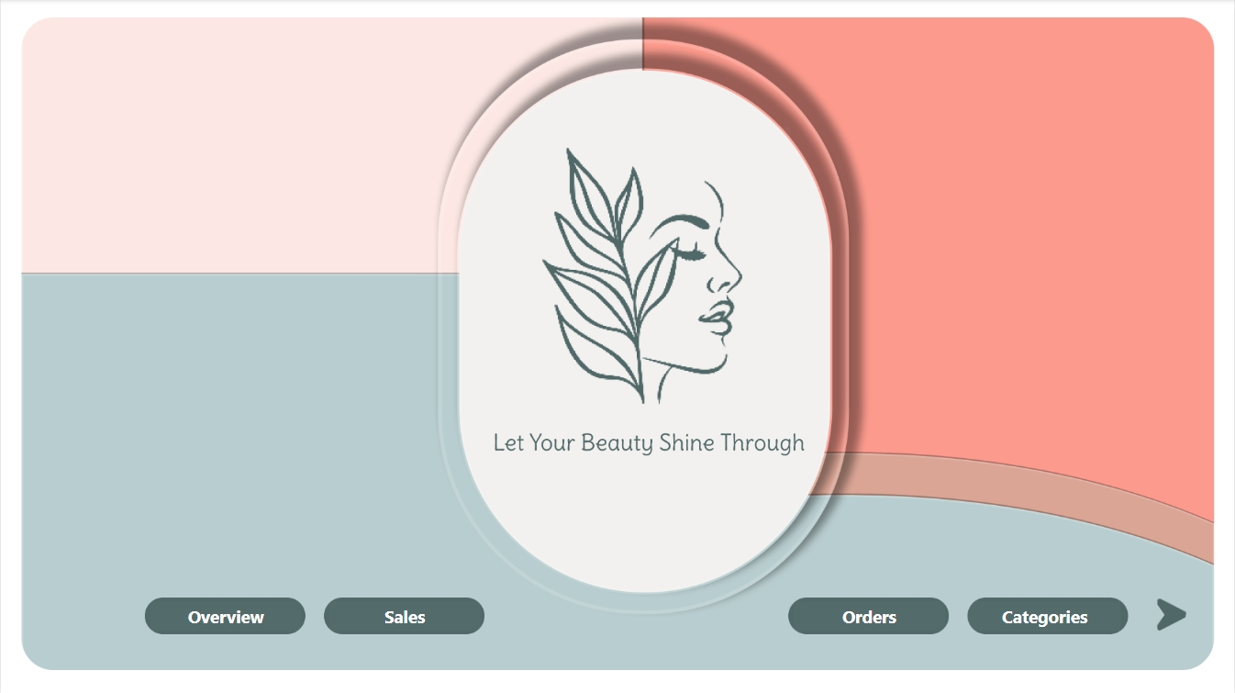

Dashboard 1 HomePage

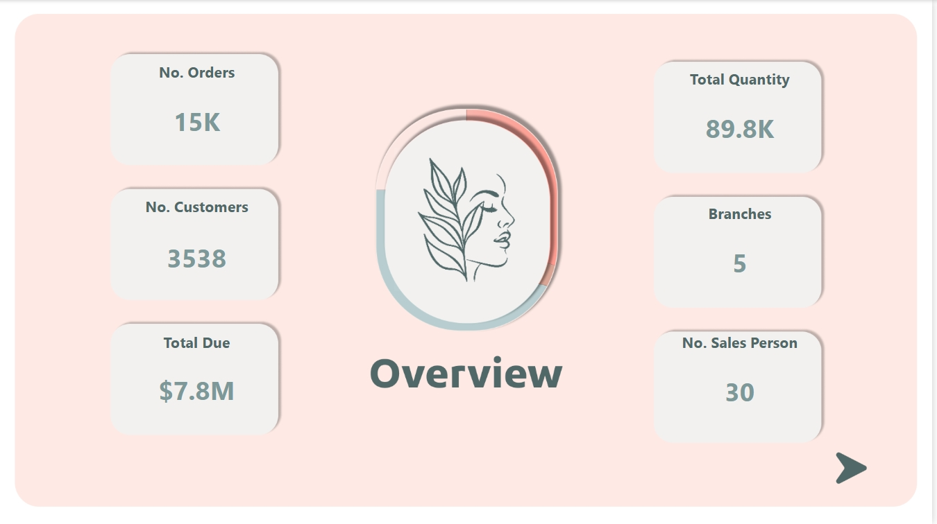

Dashboard 2 Overview

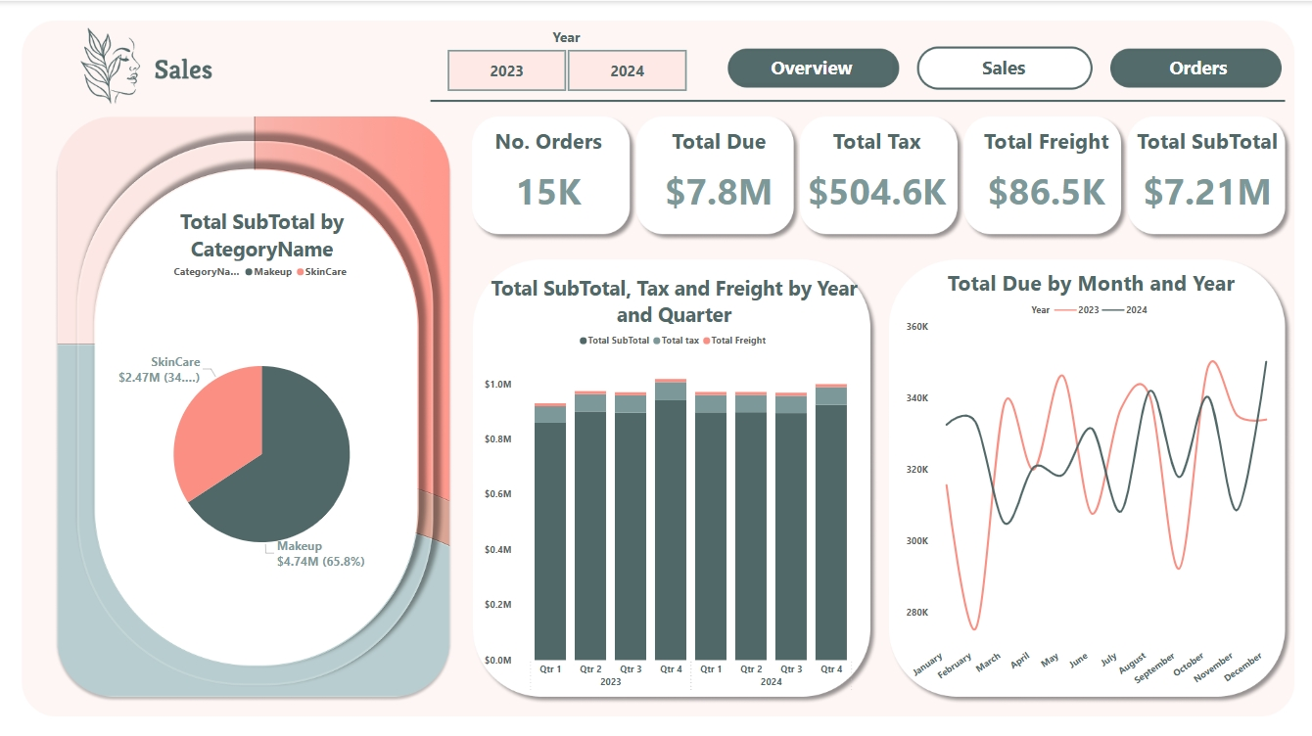

Dashboard 3 Sales

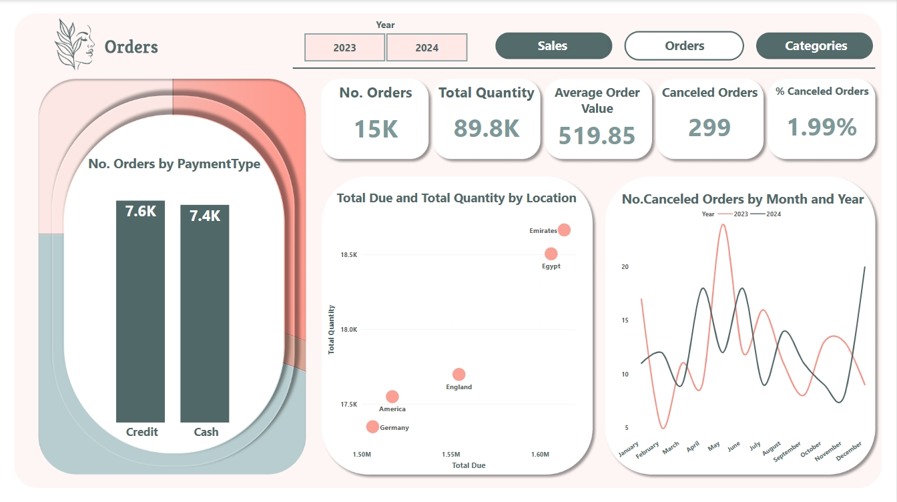

Dashboard 4 Orders

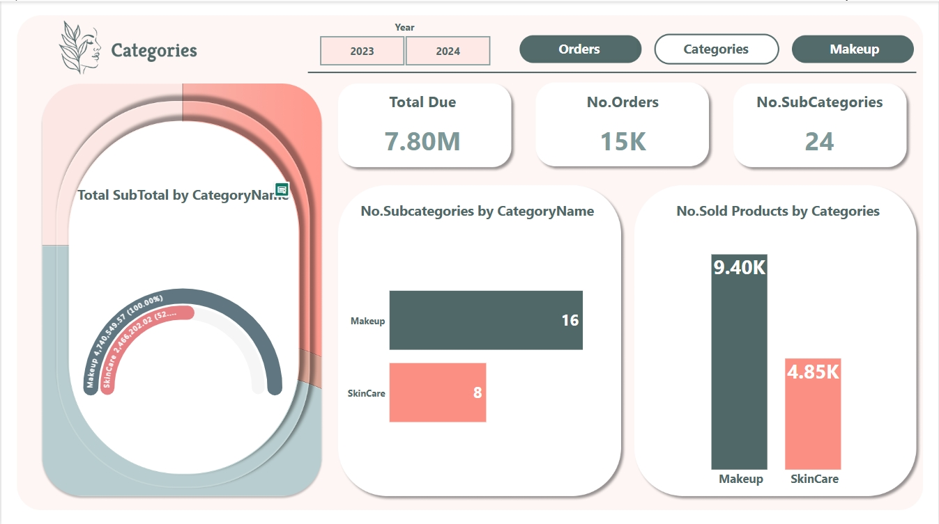

Dashboard 5 Categories

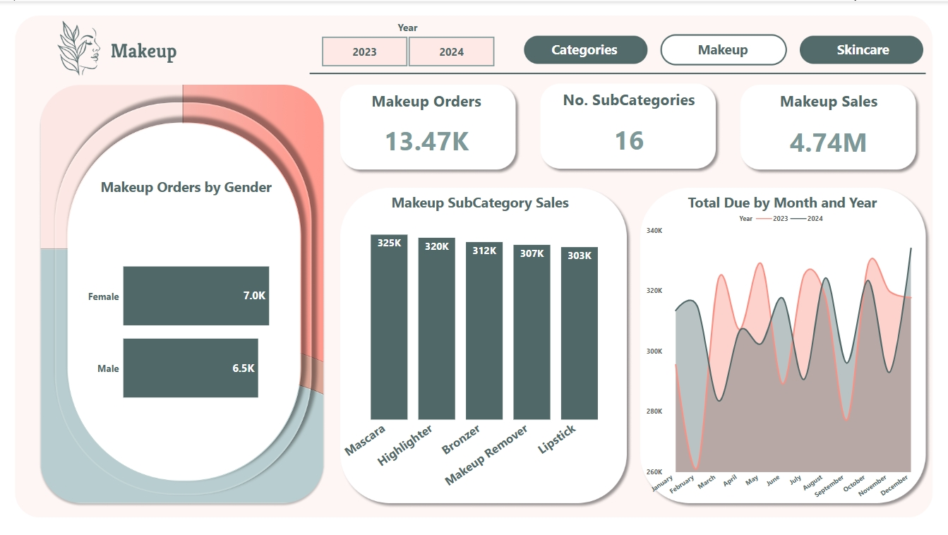

Dashboard 6 Makeup

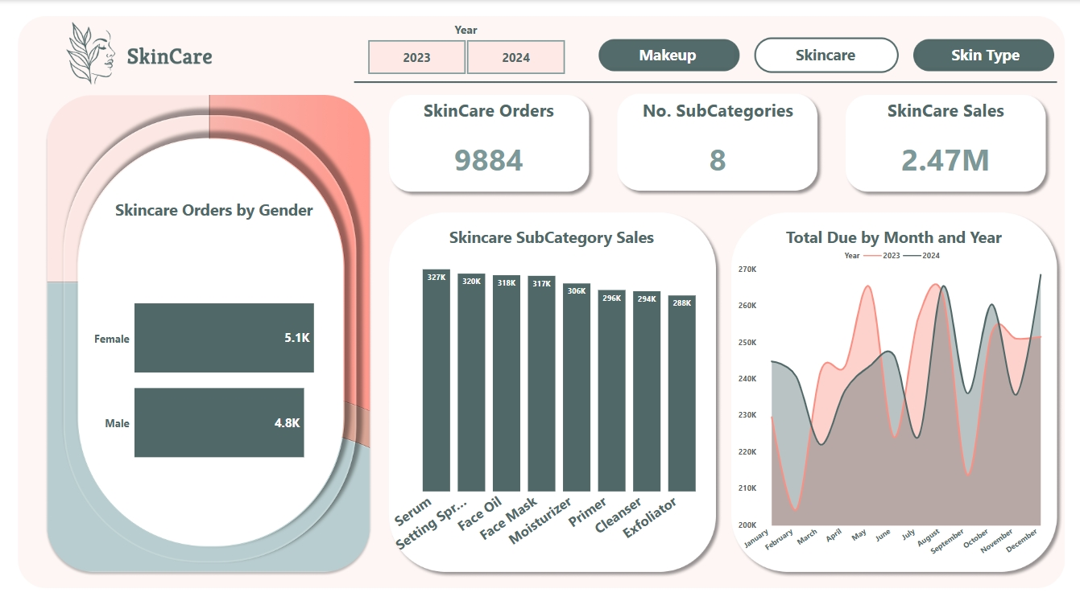

Dashboard 7 Skincare

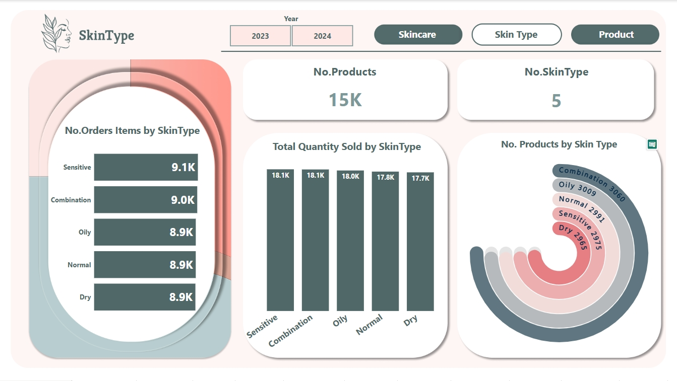

Dashboard 8 Skin Type

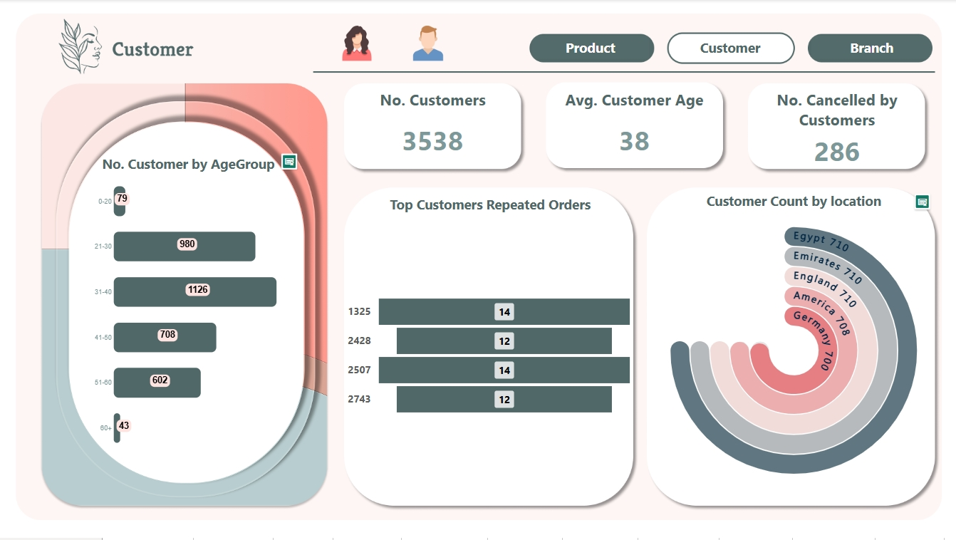

Dashboard 9 Customer

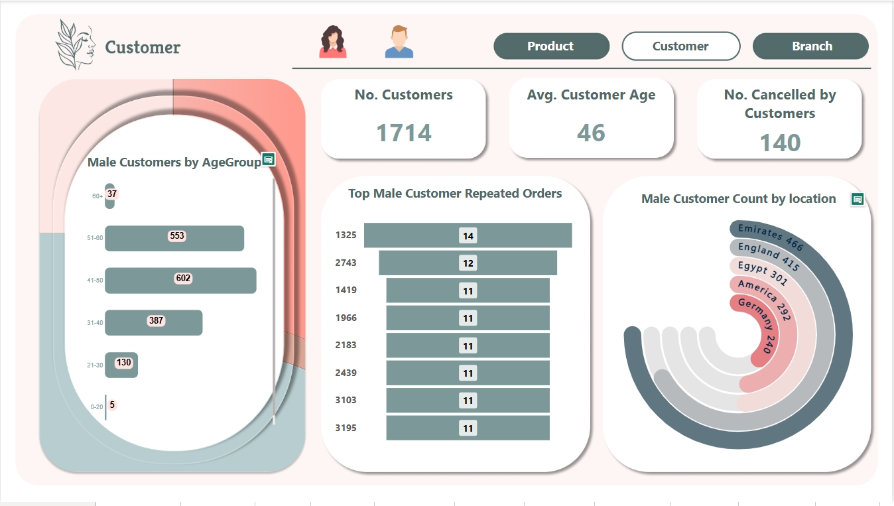

Dashboard 10 Males Customers

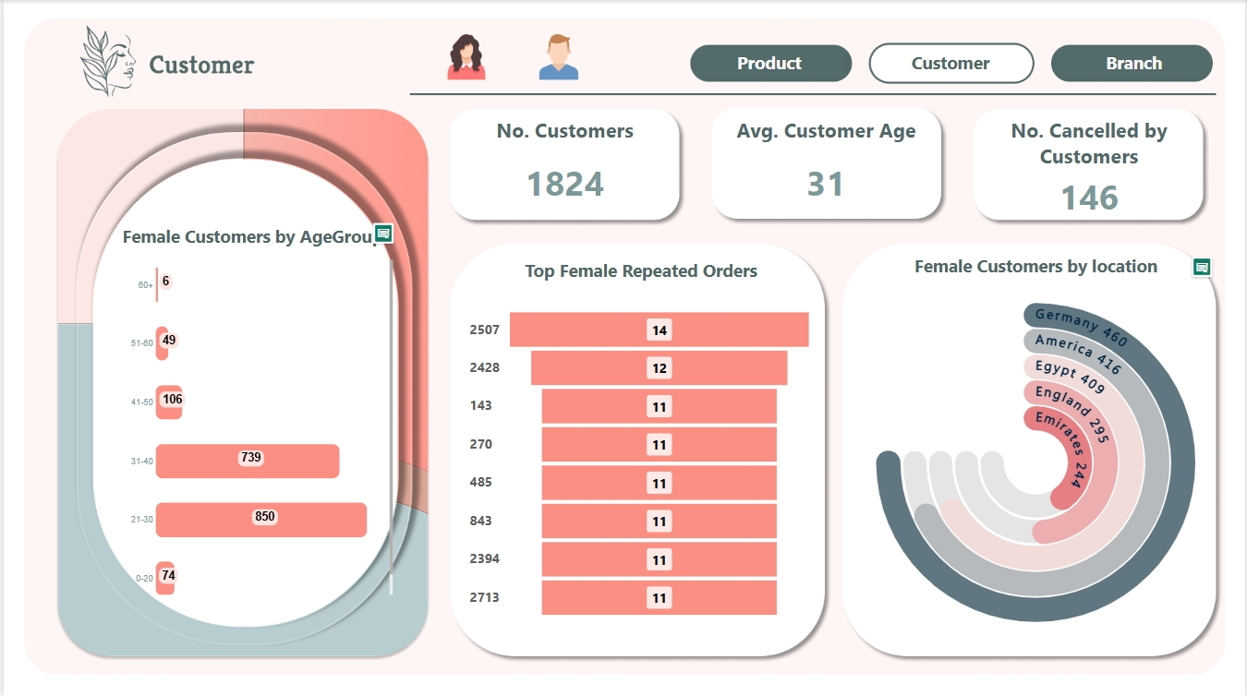

Dashboard 11 Female Customers

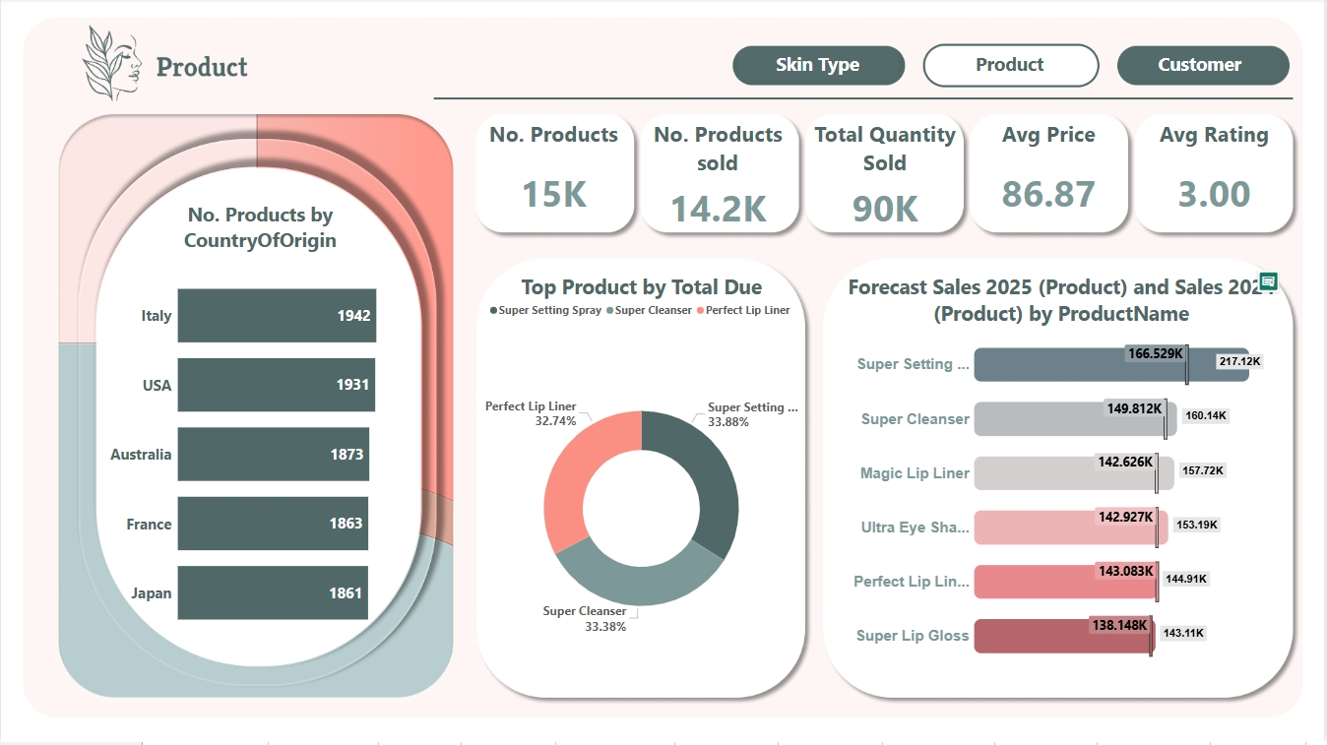

Dashboard 12 Product

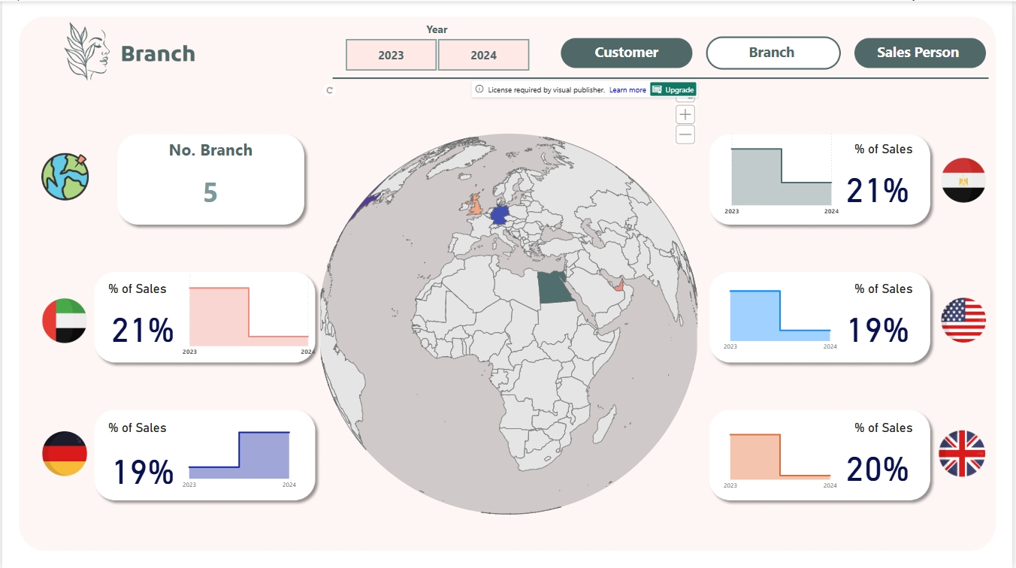

Dashboard 13 Branch

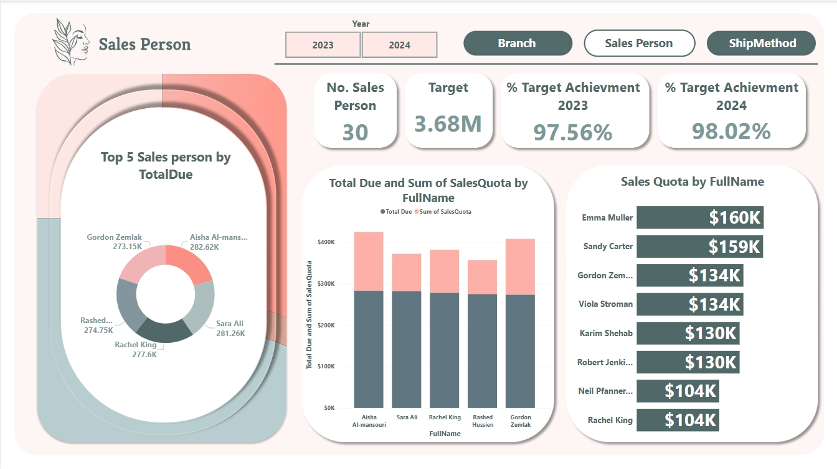

Dashboard 14 Salesperson

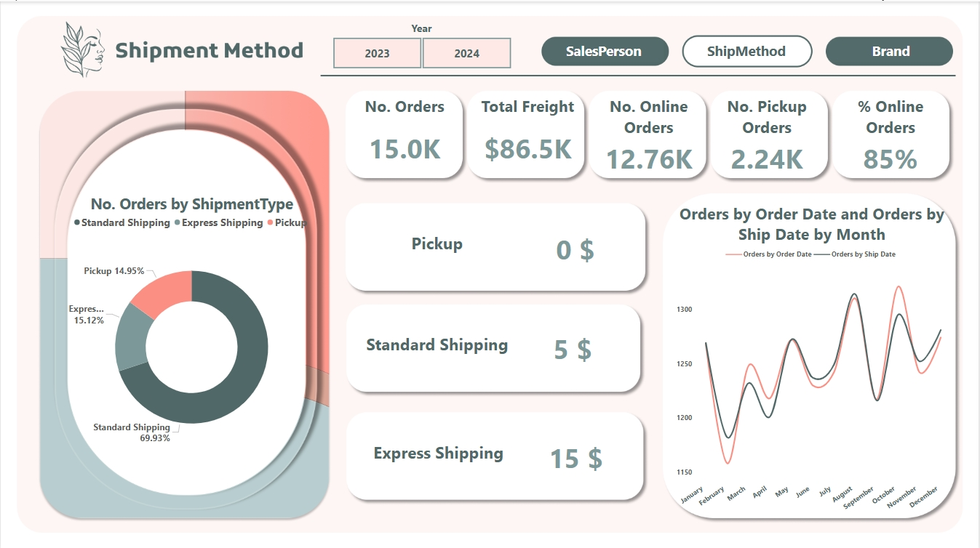

Dashboard 15 Ship Method

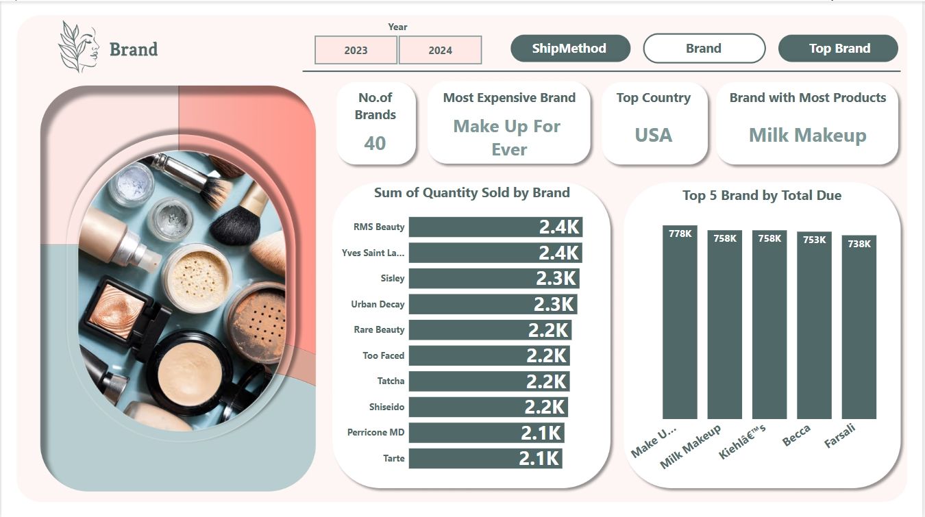

Dashboard 16 Brand

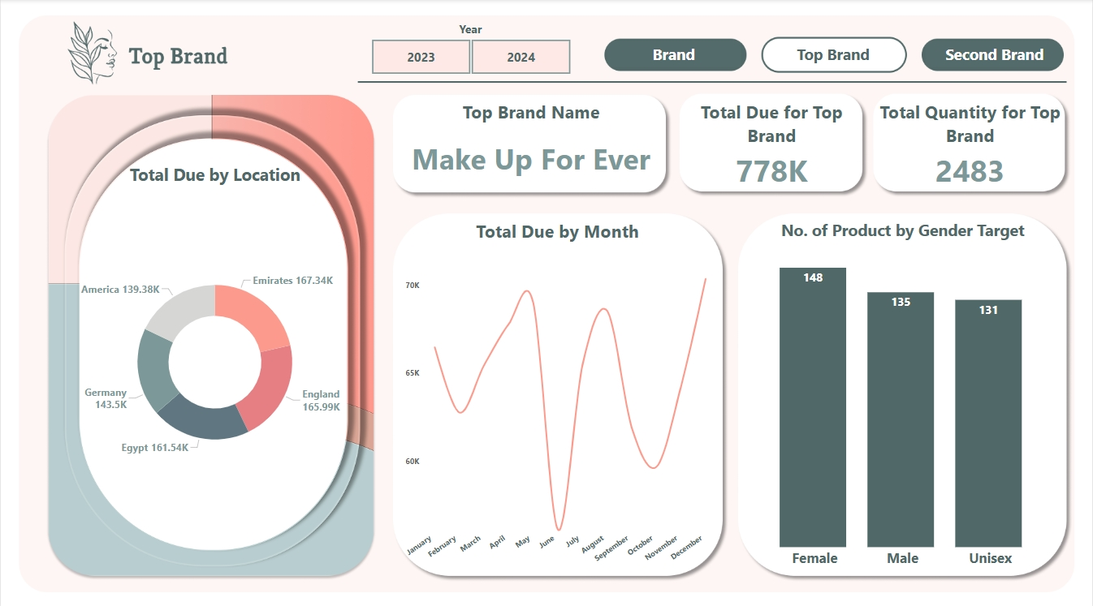

Dashboard 17 Top Brand

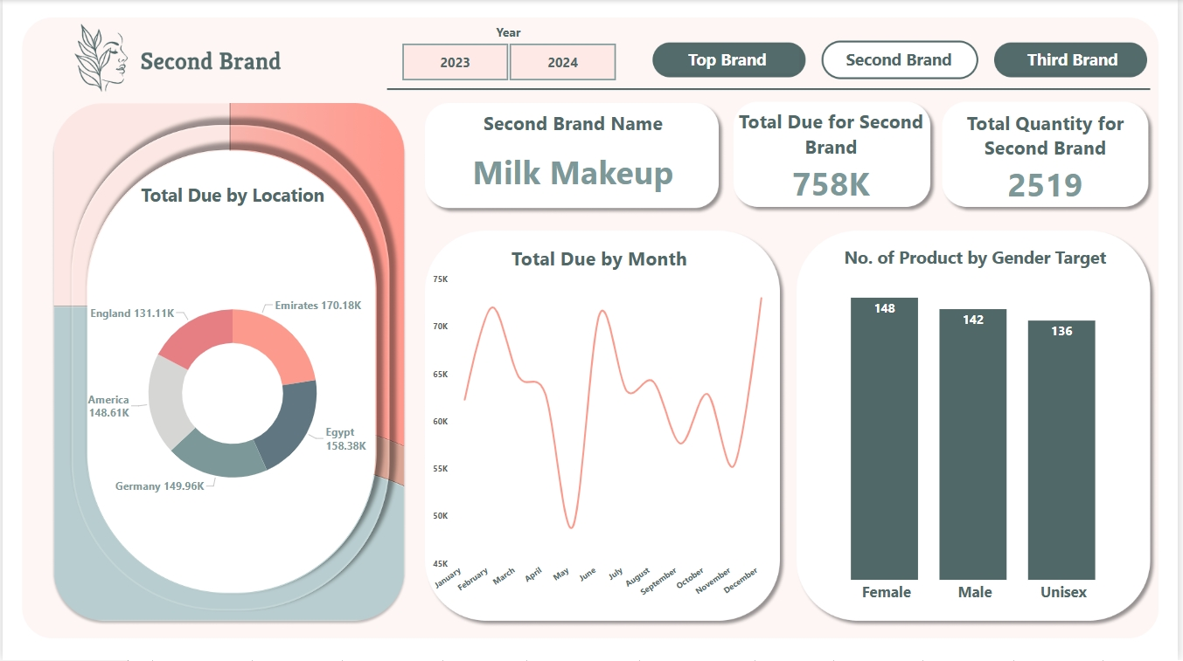

Dashboard 18 Second Brand

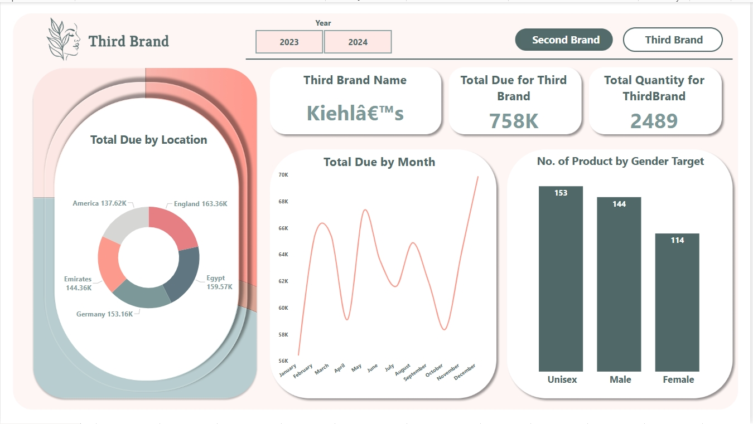

Dashboard 19 Third Brand

Appendix I Web App

